Matthieu Giroux

Economy for Kids

Scientific Coaching
by Solutions

Publisher : LIBERLOG
Publisher n° 978-2-9531251
E-Book ISBN 9791092732474
Book ISBN 9791092732467
ISNI 0000 0003 6691 801X

archive.org/details/KidsEconomy
From
L’Économie pour les Enfants
archive.org/details/EconomieEnfants
Authoring Rights 2017
Creative Common by SA License

Summary
Economy for Kids 1
About the book 3
Preface 5
Understanding the human 7
Understanding society 36
Improving Society 119
Synthesis 156
Glossary 165

About the book

I am a french writer from Liberlog at liberlog.fr and www.archive.org.
I recommend electronic ink readers not linked to a website selling books. Even if they are more expensive, they will allow you to read all the authors present in my books. Good readings !

From Same Author

- Economy for Kids
- God for Kids
- Universe for Kids
- Helping Christians
- Universe is Alive !
- Economy for Infants
- Economics' Jobs Ethics
- Become a Genius
- How to Write Stories
- Why Is There a God ?
- Explaining Christ

Visible at archive.org/details/EWrite, matthieu.giroux.free.fr and livrels.org.

On economychild.com, economyinfant.com, ethicsjob.com, riseagenius.com, howwrite.net, whyisagod.com, bechrist.org.

Preface

You have chosen to focus on the economy. Be aware that this discipline includes other subjects. In other words, this subject influences the scientific strategies of other subjects, badly or greatly. In a bad way with the monetary economy, whose only purpose is to make believe in the God money, in a good way, with the real economy, also called physical economy. Moral permits to cancel bad things. Physical economy makes it possible to tell gospels.

Physical economy consists to understand the notion of infinity, which is in life or in the circle. This real economy indicates that human society grows, that we can green deserts with Thorium and controlled thermonuclear fusion, to recycle every wastes.

With the real economy we can go to space with nuclear fusion, ecological, to leave, when necessary, our source, the Earth. Nuclear power is that is inside an atom, that was believed to be unbreakable. Nuclear energy should be learned in school, just like music, philosophizing, understanding our limits, learning to learn, economics, quantum physics, which helps to understand nuclear, Einstein's childhood and his theory of relativity, also Jean-Pierre Petit’s Janus theory. These Theories allow us to understand the universe.

If you seek the truth, helped with this book, that will help you, if you are sufficiently rebellious to become a genius, seeking your limits, leading you through the economy. Start now to write a poem, whose is half-sentences coupled ending with the same syllable, with metaphors which are comparisons without comparators, to go to a truth, then your truth, finally to the scientific truth.

Understanding the human

What Does Value Mean?
Wednesday, December 11, 2013
Our parents often tell us "Find a job to make your life !". We can see on 2013 that it is more and more difficult to find a job. Adam Smith, the actual economy’s guru, explains that work is value. Yet when something is rare, it has more value, without even working to make that.

When Robinson Crusoe arrived into an desert island, he was sinful. He lived like an animal with the first fruits he found. While he could only feed with fruits, they had got a high value.
With fire, he could survive and eat better. The food lasted longer. Then he created a bow and arrows, with a tent that could be easily destroyed by wild animals, when the fire stopped. This tent was very valuable. It allowed him, with the fire, to sleep.

The axe makes it possible to create fields
Alone, you have to spend a lot of time hunting. Animals has therefore gained more value than the fruits in his eyes. He was able to create, with research and theory, a hook. This allowed him to create a fishing rod. The animals was then put into competition with the fishes. Fishes required less work, but gained value because he had to catch them. When we do not fave to catch fishes, they have got lesser value.
Then he meets a native. While one allows the twice survival, the other creates an ax, then a house, then a net. The tent becomes useless and the house can be easily built with twice. Linking their power makes the buddies happy. Indeed the net can reduce the value of shells and fishes, because there are a lot.
Robinson can then learn writing to his friend. Their minds are not just looking for resources. The friend and Robinson raise their spirit. The profusion allows them to grow their creative reason. The energy allows to reduce working. The spirit and the creativity make them making and acting with more and more perfection.
The value is therefore resistance to obtaining a commodity, then a tool for autonomy. Associating individuals allows, with tools, to bring a lot of things. Last but not least, they work lesser with energy. Indeed a machine tool can bring even more things, and therefore less and less value to goods and commodities.
An industry makes better with dense energy, to replace the little energy we can provide into. An industry can produce thousands of goods of the same caliber with one machine. These products are perfect for simple and almost immediate use. It reduces the value’s perception.
Making Iron | 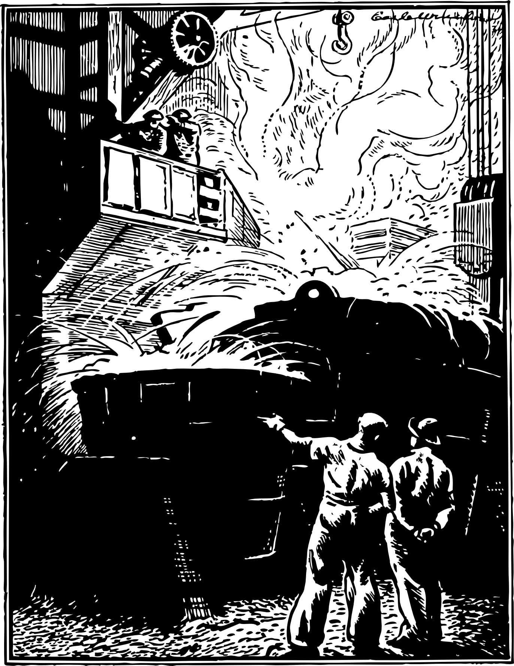

With liberalism, just a country with industries got before the others will tend to optimize its industries. It will protect them by exporting its manufactured products, in order to obtain the best raw materials, to increase the quality of its industries. China protects its industries in 2013. That's what France did during the 30 glorious years and with Colbert. China has protected its industries and can therefore benefit from the best raw materials. For China, the spirit is very valuable.

Source
• Principles of Social Science - Henry Charles Carey

My Notes
What do you wish to have? Is it important?

What is a Resource?
July 2018
A resource can provide that you need. A resource is something that we will search, then we will transform it to create goods or energy. A reused waste can also be a resource. So everything can become a resource, especially unused material. A resource is something that humans transform, so a resource is not natural, but usable by humans.
Lyndon Larouche describes how humans can determine what sort of resources will enable humans to improve their standard of living. Identifying unused technologies, then defining the resources to use for, helps to define a relative population density potential. Thus we will use labor saving, allowed while linking with industries, to define a growth’s plan.
We will use energy’s resources to supply the industries that will be protected from outside countries, allowed by a public productive money. Indeed, if the currency is linked to the production, if it belongs to a state, the nation-state using this money will support the industries. If the currency is private everywhere in the country, however, then it will be about creating money for the one who owns the currency, not to grow country.
Humans do not work to value money, but to participate to society, enriching themselves. Thus saving work realized by industries will allow us to grow more and more in the universe, which the Earth is a part of.

Source
Book : So you want to know everything about the economy ? - Lyndon Larouche - The potential for relative population density

My Notes
Knowing that certain countries have thorium deposits, that it rains on the poles and at the equator, establish a plan to green the deserts.

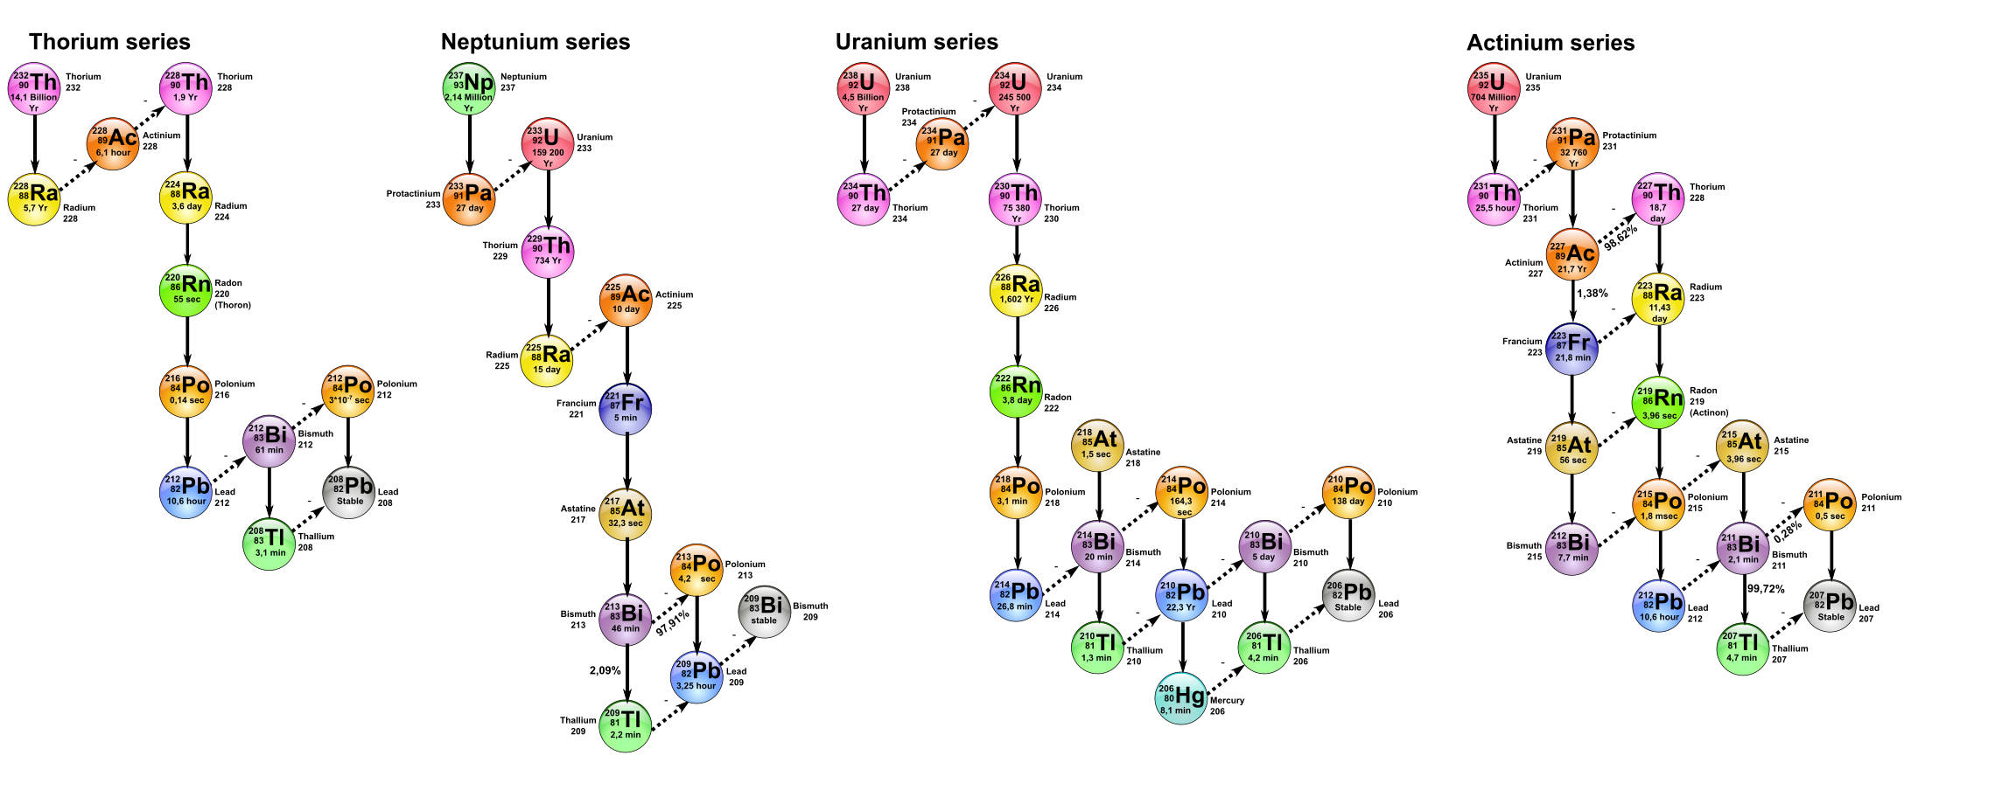
We transform atoms

What is Wealth?
Wednesday, January 4, 2017
Manyones would like to own Robinson Crusoe's knowledge. Indeed, he knows how to do a lot of things. Wealth is knowing how to use that you have. If you have something and you are useless, you are not rich. Rather, you are bogged down in our property.

So Jean-Charles Coovi-Gomèz explains that to be rich is to benefit from his knowledge and to grow. Also being poor is to be in luxury and regression, so to the short term.

So someone who has too much will have to make living that he has. He may then acquire people using that he has got. He will then want to own these people, to own his property. He will create slavery.

So poors can claim a redistribution according to the Jubilee economy, promoted by christians. There is also the antitrust law decided by United-States.

If we have something, that we can both repair and use, this object has a lot of value for us. We feel really rich then. Thus, we will want to own many of these objects to show our wealth. We create collections.


Manual work is very rich

My Notes

Which work can I do?

What is Capital?
Wednesday, January 4, 2017
Capital allows us to create wealth. Indeed money, allowing to acquire quickly goods, allows creating wealth. So for the farmer, according to Henry Charles Carey, capital is money and Earth. For the industrialist, capital is money and materials to transform.
Thus the capital changes for each job. For services, capital can be money and humans, which can be dangerous. Services can be politically lead so that their capital is money and industries. Industries must be protected so that industries can really benefit from services.
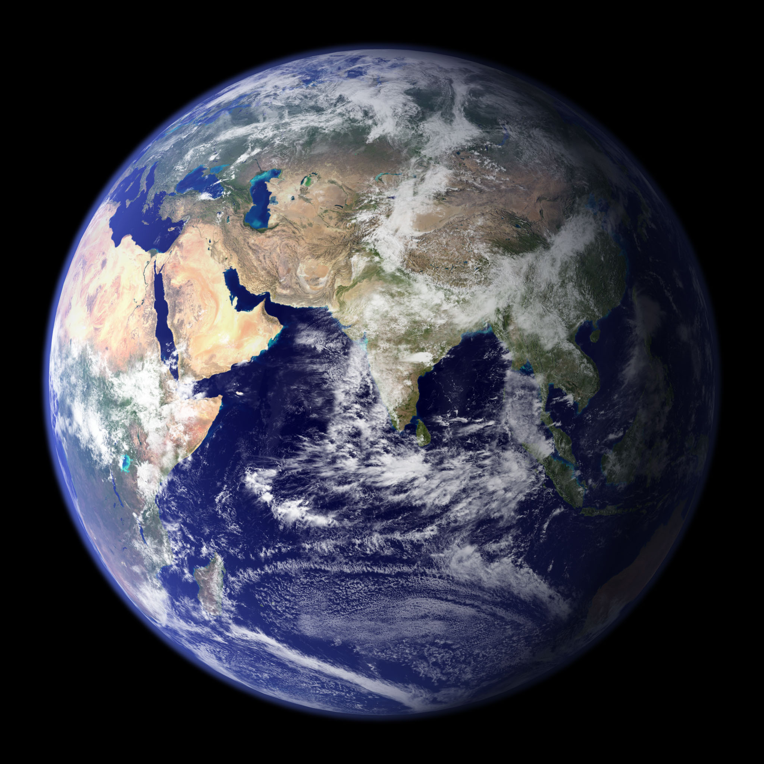
Our capital is earth on 2014

The mankind capital is therefore the Earth. It is not money, which is made from paper, unless there are some in banks. China wants to get Moon capital, to get Helium 3, for fusion, to get unlimited energy.

My Notes
What do you want to improve?

The Growth’s Culture
Tuesday, April 16, 2013
Currently the entertaining culture, promoted by the Beatles without realizing it themselves, is a culture where drugs inspire, in order to be more emotional. During the 30 glorious years, the culture was certainly popular, but above all progressive and oriented towards mankind’s love.
We remember best examples. Confucianism places this forward. The oligarchy is against this Confucianism, which promotes social rising with honesty, allowing then people to really enrich itself with knowledge, in order to grow. Our economy grows only through our ability to rise through knowledge.
The 30 glorious are an extension of Roosevelt's policy in France. Someones know that Churchill lasted the Second World War, so that Roosevelt did not see the end of the Second World War. As soon as he died, the Allied forces were better efficient. The United States had got, 25 years after Roosevelt, an eveness money, allowing the poor countries to get rich, growing gold reserve. The dollar had real productive value for anyone whom had it.
The glorious 30 had a fault. Because of the variable exchange rate, we speculated on the poor countries’ debts. This variable exchange rate meant that China was dependent on its exports on 2014. The variable exchange rate leads to slavery.
However, people was lead towards commitment. It had mankind’s love. We contributed to grow to a better mankind, thanks to great works and social security in France. There was the joy to realize the creative potential. The people were happy.
During the 1970s there were a lot of politics’ murders. The persons capable to improve society have been murdered. We know that De Gaulle, the France’s president, escaped from attacks. There is also the murder of Robert Boulin, a labor minister. In the United States, Kennedy and Martin Luther King were murdered, which led Americans to believe that roguery made it possible for them to find a place in society.
There is no longer this culture of metaphor, yet present, again, on the 1980s. These poetic comparisons express the beauty, when there is truth’s research. Money’s privatization has led to poor people’s education, where creativity has not been used. Yet creativity is that distinguishes us from the animal.
Entertainment’s culture encourages the sickly impulses, leading to our faults, because overcrowded classes prevent the teacher from changing the student, whom becomes emotional with television. Emotion and fear create war. Rationality and poetry bring about peace, while there is a truth’s research, impulsed by progress.
We should all think like scientists, to act like politics. The greatest ideas were politically engaged. The inventors of these ideas knew that politics influenced them. Every civilized person acts after checking hypotheses.

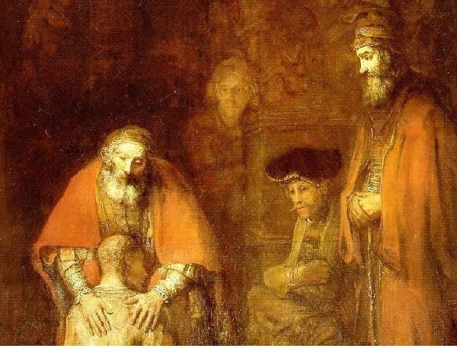
Rembrandt explains that forgiveness is beauty

Mazarin has been erased from french history books. Yet he created peace recognizing nation-states and co-growth. The peace of Westphalia by Mazarin has created a lasting peace. The oligarchy wanted to erase this memory afterwards, by promoting liberalism and Napoleon. France has become imperialist again because of Napoleon. Imperialism benefits only to a small people’s group.
The Greek culture of beauty makes it possible to understand beauty as a better future, allowing to grow human being. Now beauty is seen, at this moment, as something sensory. Beauty is however independent of our senses. For example, Beethoven created his best scores when he was deaf. Without distinguishing the beauty of our senses, we are attempted to the culture of the shorter view. Beauty is spirit’s beauty and its movement, the discoveries it gives us, to become better, seeking for truth.

Sources
- www.schillerinstitute.org/
- en.wikipedia.org/wiki/Confucius
- en.wikipedia.org/wiki/Jules_Mazarin
- en.wikipedia.org/wiki/Ludwig_van_Beethoven
- en.wikipedia.org/wiki/Martin_Luther_King

My Notes
Write about these authors.

Understanding Movement
Thursday January 5th
To understand movement, first we must be in truth‘s research, growing mind. Indeed, our mind can become heavier, creating more connection, through manual work and musical instruments.
First of all it is necessary to know that the child, when he learned to speak and to walk, used the scientific brainstorm. Indeed, he tested, made experiments, made assumptions, then, one day, he issued a higher hypothesis: "I walk", or "I speak". The child is therefore a born scientist. Yet the school does not develop the scientific spirit. But the scientific job is the job of the future.

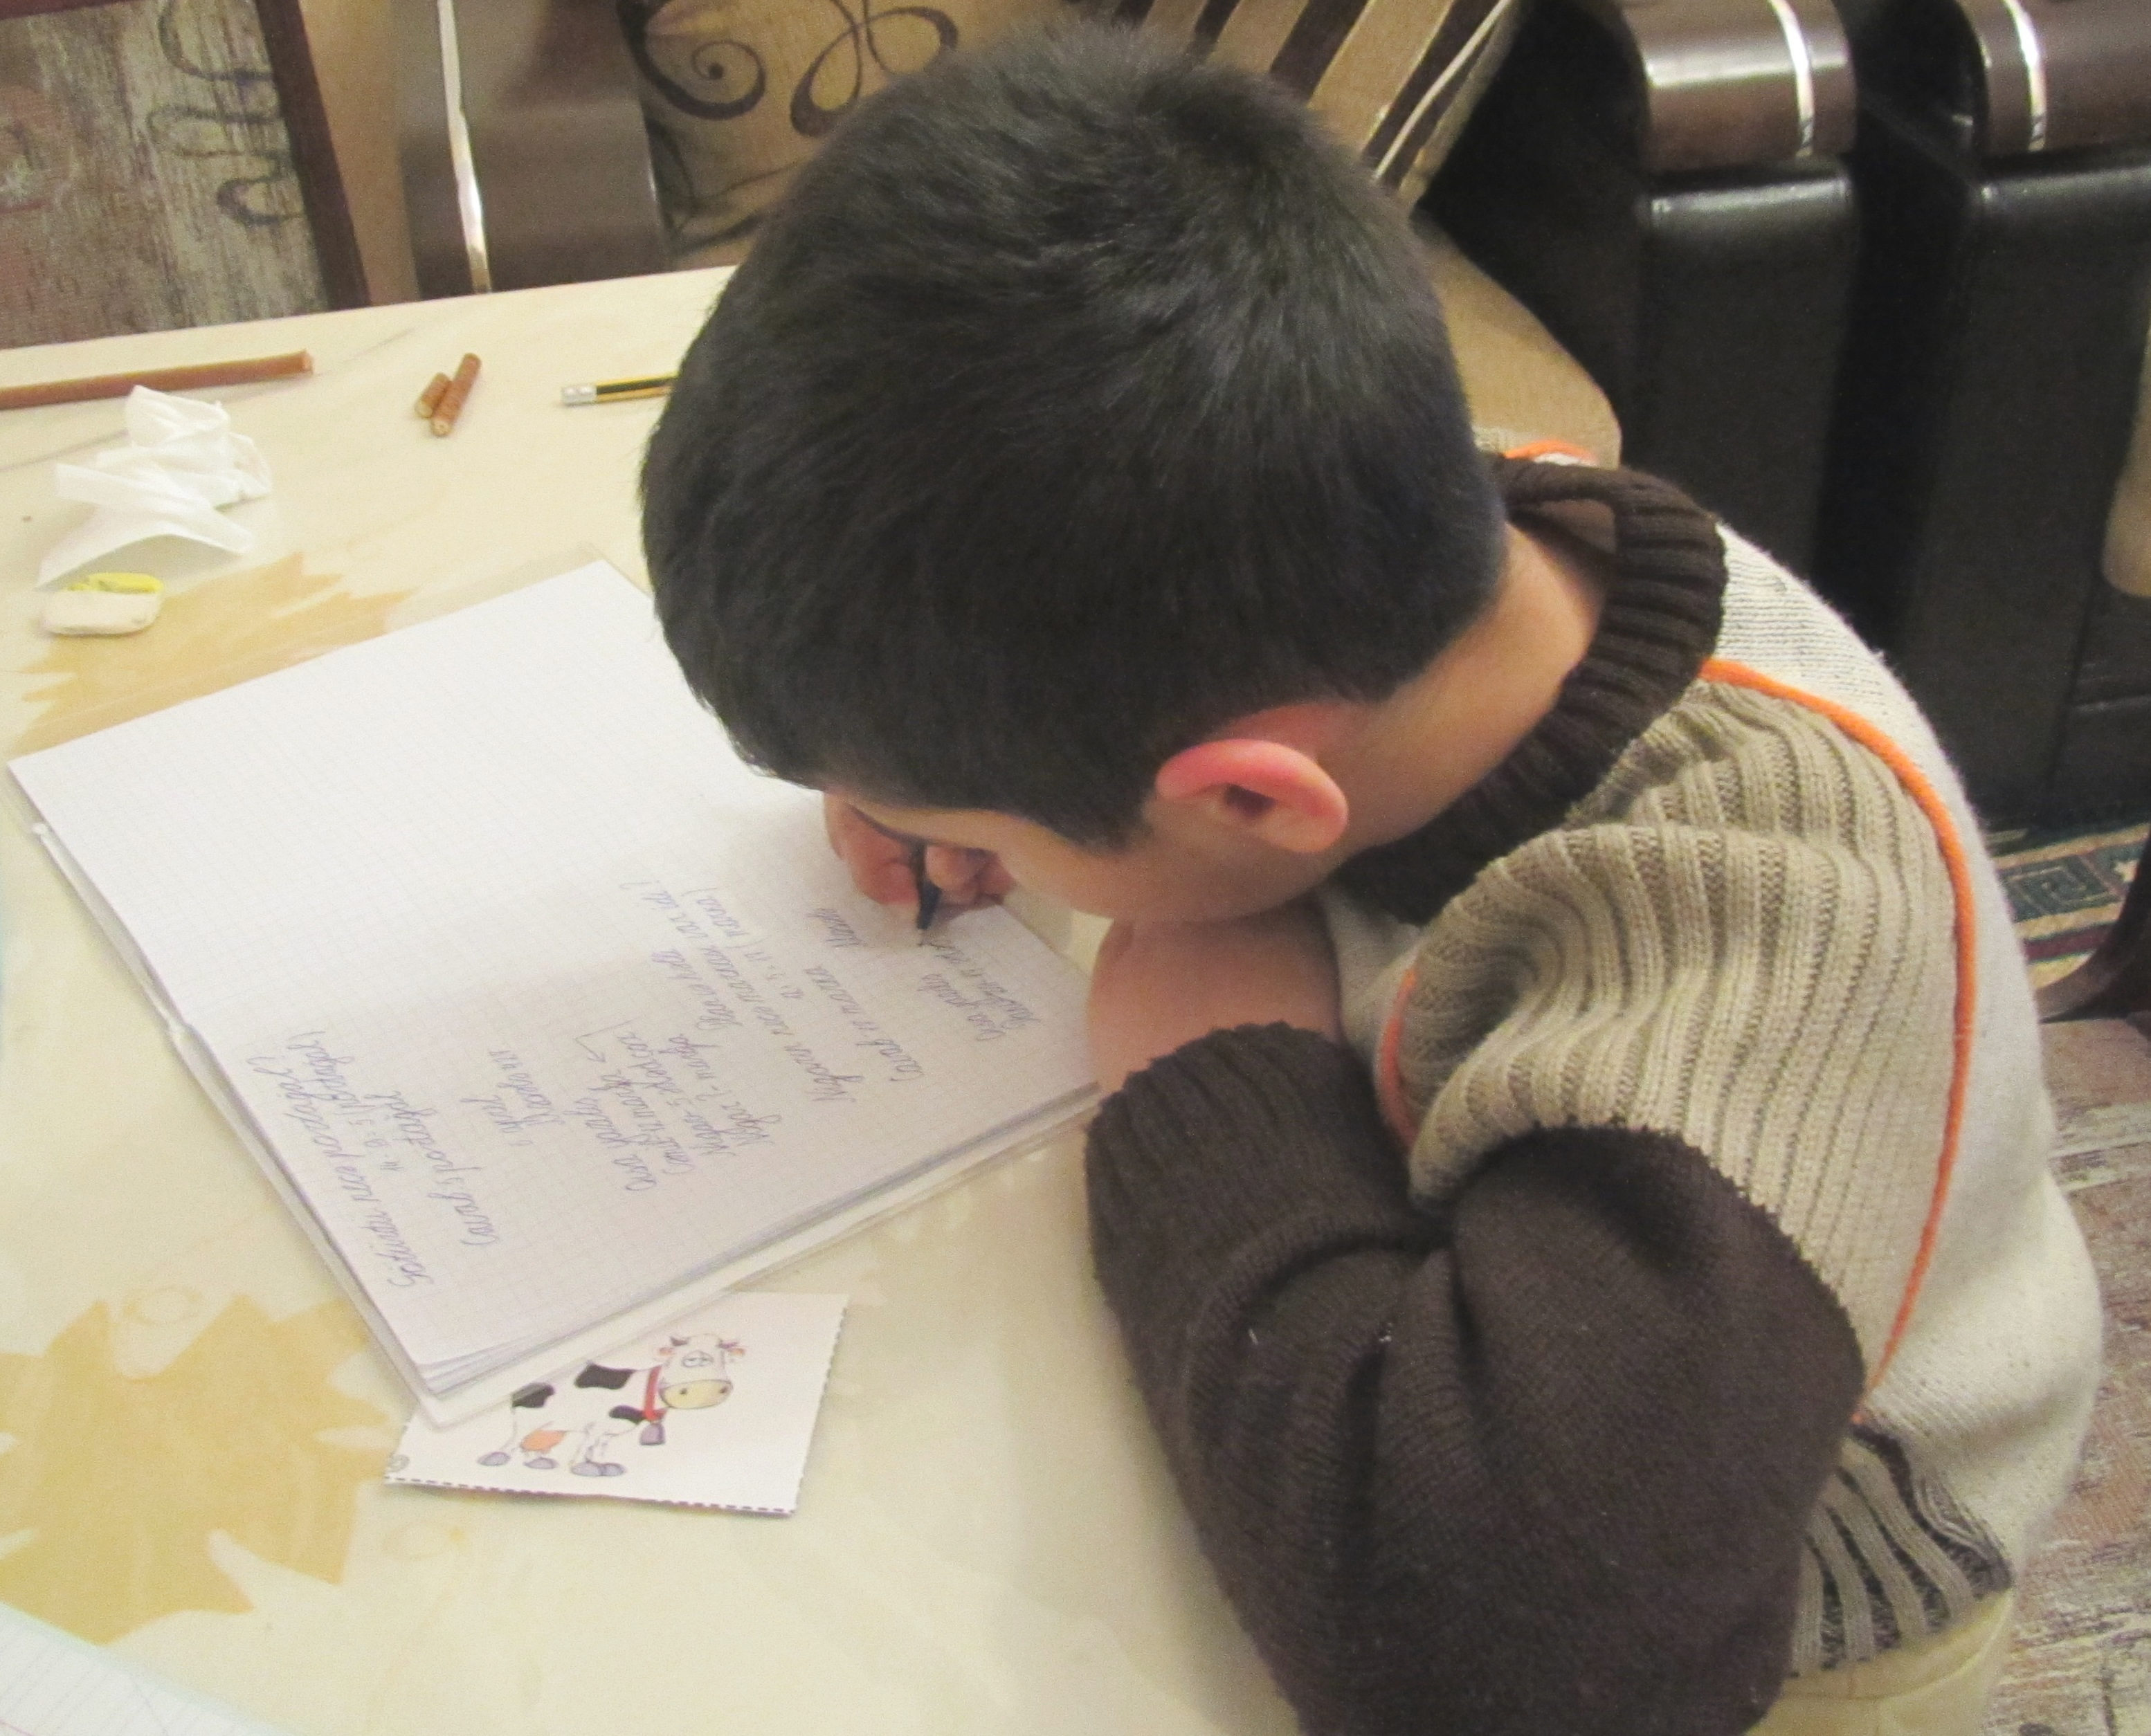
Writing a poem, saying to himself "if ..." helps to find a truth. By dint of wanting to write other poems, we end up finding our truth. By understanding nature, therefore understanding science, we end up finding the truth. Each question will lead to an answer, which will incite our mind to find another question. We will create many hypotheses. Only our mind will create a superior hypothesis, when it will link our knowledge, through meditation.

My notes

Define a theme. Write a poetry about.
Link in your mind to make a higher hypothesis.

Arithmetic and Geometry
Monday, November 5, 2012
Students realize that school education is limited. But this limit dates from the 1960s. It is therefore necessary to redesign the school programs, to go to the useful and the daily.
Our school programs are refunded each year. Often they are simplified. Other times, finance adds information. The added information is often impossible to apply on everyday life. Moreover, according to the book Leading Mind by Howard Gardner, even if the best schools make the best use of the mix and the practice, it is necessary to admit that the teachers do not check if the pupil will be able to use a theory towards a convenient.
Also the students’ lessons are very esoteric and specialized, whereas it is possible to explain very complex theories with understanding the current life.

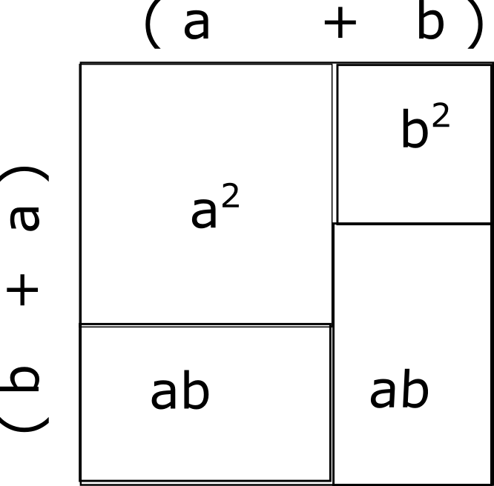
A theorem demonstrated
by geometry
Mathematics lessons will every have the same approach: theory’s statement then theory’s demonstration. The student will participate most often with the exercises. Only ambitious or docile students will seem motivated by this forbidding order.
Before, students were trying to use geometry to demonstrate algebra. You see in this article a demonstration of a remarkable identity, by geometry. Thus, with such a demonstration, it is possible that the entire classroom demonstrates, by itself, a remarkable identity. In 2012, a socialist deputy, whom could take over geometry at the heart of school programs, spends time to tell.
These complex directions have a purpose. Only students initiated with the school’s interest will be motivated. That is not told to primary. There is indeed a lot of work to tell the school’s foundations and the main subjects.
Also, poor students are largely unmotivated with the fact that graduates can not find an attractive job, knowing that 80% of hires are coopted. It is indeed difficult for a poor student, lower recognized, to be admitted for that he really knows to do.
These boring and poorly explained lessons are also meant to become emotional, so we think with the short view, so we do not know how to change society. Indeed accounting studies teach you, besides with professors whom did not practice, that it is enough to have working capital for a company to go well. In fact, you have to know each business sector.
To go further, the curves and the zones representing linear equations or inequations induce that the world can be understood in two dimensions, or that certain problems can not be solved.

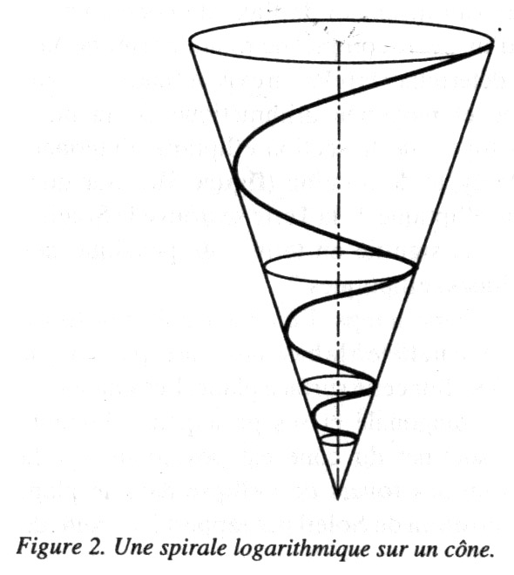 | This cone represents the perfect demographic evolution, with energy on the middle.

This does not brainstorm imagination. Now we know that there is the choice to understand more easily the infinite and our economy, with logarithmic spirals, below. These spirals can easily make sense of demographic change over time, thanks to science.
An explanation of this logarithmic spiral is in the Larouche-Riemann method. You may find it in some economics books. As you can see, this spiral uses 3 dimensions. This allows to better understand some economy‘s parameters, based on demography, with the cone, the energy’s making on the inner curve. The example above is the evolution of a ideal world’s growth for a republican society.

Sources

www.schillerinstitute.com
www.larouchepac.com
www.howto-write.com

My notes
Try to solve the doubling of the square, without using measurements.

Understanding society

Why is our society growing ?

Human society’s rise up is due to various factors. First of all Homo sapiens, since his birth, has been an increasingly creative and sensitive social individual. For example, we discovered our emotions when Descartes unlinked them. Mankind creativity has been revealed while using nature, revealing powers. Understanding nature has allowed homo sapiens’ rise up. When Africa was a desert, the first 1000 homos sapiens controlled the tides in the African beaches, then have been to Namibia. Then they have populated planet, by mastering fire and marriing.
When homo sapiens is front of seemingly insurmountable difficulty, Homo sapiens has this curious ability to gain immense sensitivity, which can either cause disorder or awaken a practical and cognitive creativity, that allows him to anticipate others and his environment.
Tidal control has created homo sapiens. The prophets known to the human race probably existed in a certain way. The writings have also prophesied these humans. Indeed, this sensitive creativity awakens the ability to think with others through dialogue. This dialogue, driven by a big problem solved, which could have wiped out other less prepared homos sapiens, reveals every day a truth with others. Thus these humans speak of faith in the other, because telling with people and the worst examples strengthen their ego, their creativity, therefore their faith. The same dynamic could also be found among the great mankind discoverers and scientists. For them, the glory will not really be that they are remembered. They will be people remembered for their words or writings, to grow society, in order to do as well as life’s creator.
There is also in the human the desire to go into the unknown, to discover it. Homo Sapiens is not afraid of differences. Asian has married other human species more easily. Chinese calligraphy began our philosophical journey. The Amerindian succeeded in diversifying human genes by discovering the most remote lands to Africa. Also Africans kept the greatest genetic heritage of humanity. He has this unparalleled faith in life, in society, in nature, in science, therefore, in spite of the challenges that have gone through. Homo sapiens has created an advanced society while living in a difficult climate and a rich nature, hardly modified. The Greeks continued the human philosophical’s rise up. Turning swamps into fields permitted them, after africans, to create new great growth, with a better living.
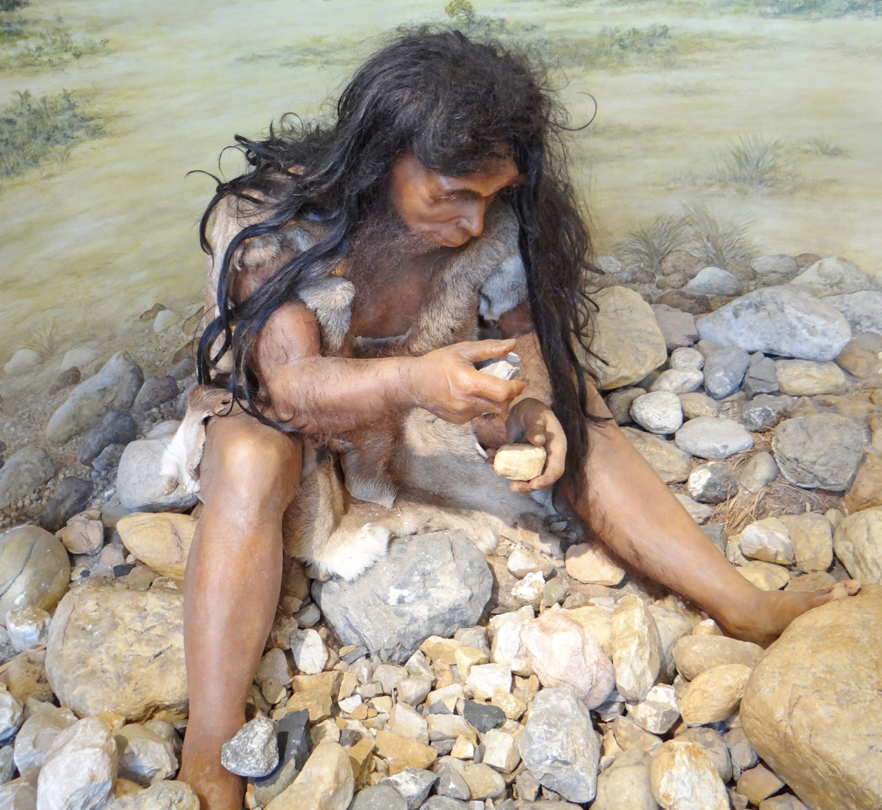
Reconstruction of Tautavel's man carving tools. Room dedicated to the first inhabitants of Roussillon in the Museum of prehistory of Tautavel
All animals are afraid against fire, except humans. Here is human economy’s begining. Fire Control kept the food longer with easier eating. It allowed more time to think, giving us the will to try more and more to modify nature. The axe allowed the sedentary and the first houses. Even so, our ancestors spent a lot of time surviving, working a lot to get a little. However, humans specialized 40,000 years ago, at the time of a good demographic.
The first villages were established through livestock farming and crop, with organized and specialized societies. After biomass’ energy, mankind then uses the energy and the benefit of the breeding, to increase people with less effort. It is up to a society that respects its citizens to respect animals. Human society can only exist through the benefit to others.
Then petroglyphs created the hieroglyph’s handwriting used at first by the nobles to grow themselves. The association between individuals and societies has grown. These various good technologies can be summarized as follows: labour saving through energy, through elements’ linking, then of humans and societies.
The societies that have the most self-power over the labour economy are also the most cultivated and the richest.
However, educated leaders are often not as sensitive as their parents, because they don’t solve big problems. This defect in all our societies then reveals our animal character. This defect is solved with creative and politicised people, often few, because to be creative requires to confront to others’ truth. If this population is harmed, a society or civilization is destroyed. If the creative population is increased or favored, great industrialists and then scientists take place. They will grow creative sensibility, in disregard of the lobbies or jealous powers. This is how human society is constantly growing, with the writings keeping that has been used.
Closest complementary persons or families are, better dialogue and linking will be fostered, better intelligible and material wealth there will be, better dialogue and linking will make it possible to produce complex and high-quality tools or goods. A society that has understood this issue will grow very quickly. Great names will be known in the sensitive and creative population. Thus a society, called empire, which will individualize will be lost because human understanding himself defining, bonding, telling, asking. Links between ideas allow to link elements.
There are always elements that ask to reveal their powers. There are still fields to be created, more than we can imagine. Mankind has this creativity that will allow his society to equal God, discovering universe organization.

Mes Notes

Discover new prehistoric museums.

Growth history

Human took risks to use fire, in order to protect himself from animals. Then, livestock farming and irrigation led to a new growth. People gave their life to acquire goods. They became slaves to acquire. Slaves' debts were then recorded, creating scriptural money.
Chinese, then Greeks, created the currency, Chinese' notes, then Greeks' coins. Chinese used a hidden tree for notes. Greeks used metals for that. Chinese currency was mainly valued because it was able to acquire with it silk in Europe. Russia was interested about other Chinese goods.
Chinese emperor applied his seal to banknotes, validating Chinese banknotes. Thus, Chinese finance was not created, also thanks to Confucianism. Chinese created the first steam engines. But then they were attacked by the Huns.
Nicolas De Cuse, who has grown Infinity notion, then the astronomer and technician Kepler had both revolutionized European science. Kepler had found some planets' paths. Then he spoke about harmony, harmony meaning mathematics. Kepler thought also that space was organized, so it needed a soul or souls. Mathematics harmony were used by Jean Sébastien Bach. He created the Well-Tempered keyboard. Later Leibniz and Pascal discovered him.
Under Louis XIV, Colbert wanted to restore cathedrals' movement, protecting France from British Empire. He decided to destroy the Fouquet traffic, to protect French manufactures from the English imports. This led to create French industries' future. But Colbert decided to export only luxury. Then the other factories became trusts in England to get rich. A trust is an delegated managed lead by a paid employee. This management dates back to Crusades, when the knight left to war, delegating his owns to an employee.
Also under Louis XIV, Denis Papin and Leibniz created coal's economy, later allowing the train and the steamer. Leibniz improved the infinity's concept of De Cuse, to speak about growth, through labour economics.
Lazare and Sadi Carnot created thermodynamics, under Napoleon, to later create pistons and the heat engine, much more ecological. The heat engine allowed great works. This science was hidden for 40 years, discovered and censored for a part by Kelvin.
In the United States, a public productive currency was created, constitutionally linked to a public National Bank. Hamilton indicated that this bank would turn debt into credit. That happened.
So, Napoleon created the France's Private Bank, so financial bank. He was used to make war. But Lazare Carnot had created Polytechnic, MINES and the most colbertist schools known as CNAM. Polytechnic created thinkers going against Napoleon. CNAM made it possible, among other things, to investigate French society, as a Colbert should have done.
On the nineteenth century, we discovered that energy was created by Labor. So we defined work as energy. Leibniz's labor saving concept was thus allowed greatly with a more dense energy. Henry Charles Carey then defined physical economy's leading words, words defined in this book.
Henry Charles Carey was read in many countries. Carey allowed the worldwide train's growth. He was exchanging with Friedrich List, who allowed Bismarck's productive economy. Meidji ERA in Japan was also strongly influenced by Carey.
French finance was very interested to create again a Colbert system spread across Europe. The young Eiffel was financed to promote French finance to show colbertism again, realizing that it was less valued face to Elisabeth's finance, therefore it also benefits from the productive currency‘s restore.
Germany had, however, understood Carey's creative and productive reason to create a Nation-State. The Colbert system allows being competitive itself with the first system created. So wars have no interest with this Nation-States’ system. The growth of this system are mostly through private monetary recessions to create industries, knowing that the Elisabeth’s system can do that also. These recessions can then benefit to Colbert system through a public currency that grows industries, even if this system splits. The French Colbert system should be helped purging finance that took place only once in France.
Jean-Charles Coovi-Gomèz, a student of Cheikh Anta Diop, says that after the law on secularism, France had to enforce the individual right as soon as possible, through infrastructures and laws. There was moral’s manipulation and a trading system, more or less moral, due to French system. Also we could gainsay using Colbert’s laws, even if they were not respected. So Mr Coovi shows that this system allowed early twentieth the strict respect of individual’s rights, including that of the american’s creative reason necessary for industries. Slavery was therefore necessarily prohibited to respect this French system, system financing or requesting financing to this respect, with obviously news used by anyone. France is the most interested to finance and respect. France is a target country for and against finance.
Thus, Eiffel allowed tests to create better-made planes than German ones. He was probably criticized to not invest in planes during the first war, an absurd war by the way.
The Colbert systems were for a long time the only private systems that are interested to finance industries during a crisis’s period. The war pays off mainly monetarily, rarity driving up prices.
Franklin Roosevelt took advantage of Carey's last schools to clean up the banks through a Glass-Steagall Act, consisting to split deposits, that is, taxpayers' money, from speculation, that is, financial money. George Boris wrote articles about Roosevelt. Roosevelt did not read Keynes, but Carey and Hamilton.
We discovered nuclear power. This dense energy allowed a global growth. Franklin Roosevelt wanted to grow Africa, during the war. Marshall plan, which was a monetary plan, was financial and was used unto Europe.
Georges Boris taught Léon Blum, Pierre Mendès-France and Charles De Gaulle. Charles de Gaulle and the communists split banks into three parts, that is to say, separated the taxpayers ' deposits from the loans, therefore debts, from speculation too. French economists are frightened that loans do not allow Roosevelt's banking splitting.

My Notes
Write and search about Colbert and Denis Papin.
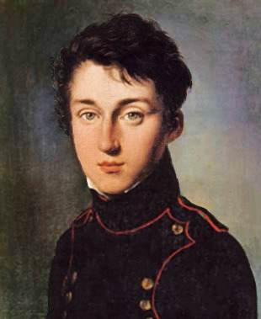
Sadi Carnot, here, and his father Lazare are not enough known in France.

From Cell to Society
Friday, February 10, 2017
In the same way that the individual is composed with cells having a specialty, the society is composed with individuals having a job. Everyone is linked to everything. Each individual is a cell of the body society. Each company is an organ of this society, acting for itself and for others, apart and for the whole. The more specialized the bodies or jobs are, the more the body or society can achieve different goals.
Thus, it is about saying that a company must be directed. Otherwise we could not coordinate cells, humans. So we could not answer to the short view. Just as we do not know why life is organized, we do not know why society is organized. Thus each individual acts for himself and the whole. If it does not, the other cells must hunt the cell or the individual. The cell will use immunocompetence. The human will use cops. It will then be for the cell or the human to feel the way to lead instead participating, so that the management gains control at all.

The cells reproduce as the first animals reproduced
It is very difficult for a body to hunt cancer cells. Indeed, the cells behave individually. Society, then, can not receive help from outside, unless from God, to reorganize itself. This raises the question that whether God organizes our society when it goes wrong.

Readings
https://en.wikipedia.org/wiki/Monadology

My notes
Why should society organize itself?

Physical Economy Story
Friday, July 19, 2013
The physical economy explains how goods are produced. It also tells how it is possible to grow people, increasing the living’s standard, thanks to human creativity. Human creativity acts on agrifood and industrial production.
In Ancient Greece there were many free citizens. The ancient Greeks used slaves for their industry because there were no motor machines. This seems obvious to you, but this principle of lesser action is questionned today. Indeed, in 2013, many complain about machine tools. The actual problem is that France does not grow industries anymore.
Slavery and wars have caused the implosion of Greek and Roman civilizations. This ended temporary Greek scientific discoveries.
The Greeks used geometry a lot in mathematics. They thus defined the principle of least action. This principle makes it easy to create geometric figures. This allowed them to grow their minds to understand how to build into space. Even today, geometry is essential to understand the infinitely small. But it is insufficiently taught since the 1960s.
In the fifteenth century, Nicolas de Cues defined the principle of maximum minimum, linked with the transformation from arc to circle. This demonstration behaves from Greeks least action’s principle. Nicolas de Cues also demonstrates that it is impossible to create a circle with a polygon. He therefore brings ahead the infinity’s notion, present everywhere in the universe, in life also.
In the sixteenth century, Kepler geometrically determined the weight of the earth understanding the elliptical planets' ways of the solar system.

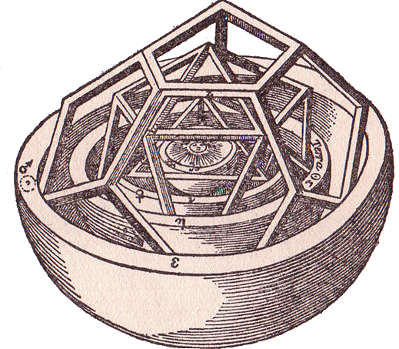 | The cosmographer

Before Kepler, the planets' ways were not understood. To understand the planets’ ways, Kepler created the cosmographer. Creating the cosmographer, Kepler thus created the foundations of mathematical physics, which dependents on geometry. Kepler could never have determined the mass of the earth without his cosmographer.
However, on 2013, geometry is buried in french high schools. They say they want to specialize students. But many students become dependent on their own knowledge, and are unable to grow themselves like science grows. Still, finding new ideas makes the scientist. Kepler's geometry has, however, led to great discoveries.
Leonardo da Vinci created many machines in the fifteenth century. You can see all his creations in different pictures’ books. Leonardo da Vinci has created a lot of kinds of gears, to create a steam engine. He used the less action’s principle, allowing to gain efficiency.
The steam engine will be finally created by Denis Papin in the seventeenth century, thanks to the discovery of stronger alloys. Denis Papin was the Leibniz’s collaborator. Leibniz wanted to use the least action’s principle to revolutionize mining. Leibniz's works range from philosophy to science and economics. Leibniz sublimed the least action’s principle. This principle is present in the physical economy to solve slavery problem. Indeed the machines of his century, even if they brought qualified jobs, required a lot of physical work.
Leibniz supplied his works to the Russians with Peter I, whom sublimed Britain in the eighteenth century for mining. Christiaan Huyghens, another employee of Leibniz, will allow to create combustion engines, much later, however.

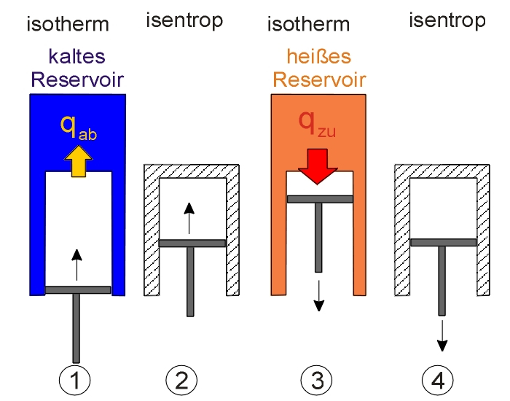 | The Carnot machine  looks like a piston

In the nineteenth century the physicist Sadi Carnot understood that geometry allowed to encompass physical phenomena, in order to build machines.
He created the first system to understand how to use heat, whose we still have discoveries to do. Sadi Carnot shows very clearly that air contracts and relaxes, in his machine excited by heat.
This system makes it possible to understand thermodynamics, the heat’s science, using least action. Thermodynamics led to create more combustion engines. Thermodynamics consists to say that there are heat movements, even if Lord Kelvin wanted to show that there should be none after a while. Lord Kelvin's work tried to make it seem like everything was becoming scarce. This is now against scientific findings.
Here again, the geometry and the least action’s principle makes it possible to create the combustion engine. The combustion engine prototype will allow, with the oil, to give us the possibility for the human being to abolish legislatively the slavery. The engines today allow us to claim a creative human civilization. Here is that Alexander Hamilton, Friedrich List and Henry Charles Carey established with the state bank. This bank creates a public productive currency, a credit for major works, which belongs to the people with a useful protectionism.
The books of Friedrich List and Henry Charles Carey are a public domain work. In these books you have all the economic systems explained. In Friedrich List’s book, the part on Spain and the Methuen treaty learns a lot about the flaws of the monetary economy, where we see that Adam Smith, the guru of the current economy, is really an notorious idiot, whom does not even know how an enterprise builder makes.
The Larouche-Riemann method is a demonstration of Nicolas de Cues's work on the self-similar conical action. Leibniz began work in this theorization of the human economy with circular action. Riemann continued the work, allowing Lyndon Larouche to clarify such this usefulness method, allowing also to see the crisis arriving, while proposing human growing. This circular action now makes it possible to understand the economic and human demographic growth. It replaces the 2-dimensional graphs, which prohibits to understand how human economy grows.
Our creative reason has always distinguished us from the animal, as Friedrich Schiller explains. It is also possible to create a society where every citizen grows, a society of researchers. Useful protectionism, which protects industry and agriculture, provides access to this kind of society protecting human creativity. When we follow creativity, we want to grow.
The monetary economy, squeezing production with the famous quality-price ratio, squeezes industries, breaks any possibility of protectionism like Roosevelt did, then like Mendès France or like De Gaulle did. These men allowed people to grow their creative reason. Roosevelt protectionism squeezes every usury’s form, especially with a fair currency with real productive value. Roosevelt had this understandable desire to grow Africa. France unfortunately did not want to do that. When we inspire the others we inspire ourselves.
The physical economy explains that a human economy must be managed humanely. That is while protecting and embracing human creativity. The physical economy is an economy encompassing the least action’s principle, thanks to dense energies. This is called labor saving, thanks to energy flow’s density. The machines will, indeed, allow the workmen to be quieter, still it is needed them to be favored.
The findings above have allowed a relative population density potential. That is, they have or would have allowed the population to grow raising the living standard. In other words, a population that uses an invention with a higher demographic potential will grow a lot, if it makes the right policy choices.

Readings
https://larouchepac.com/20160315/leibniz-iii-physical-economy-and-vis-viva

My notes
Why can we grow?

Energy Story
Saturday, October 20, 2012

Unlike those whom believe that money is a wealth, unless it is only a means of having it, energy is the essential basis of our economy. Indeed we can remember the technological revolutions, as the taming of fire and animal, then the energy provided by the sun and water, then fossil energies, finally the evolution towards the science of isotopes, nuclear energy, which is an energy that constitutes material.
Why energy ?
Every energies are natural, and nature also contains the whole universe. We are now trying to explore it. Humans only handle nature through science and their creativity.

So we can be a lot on the planet thanks to energies allowing to:
- Heat to prevent disease.
- Overpower nature with industrial tools and science.
- Give us time thinking about growing our science and our industry.

So we can say that our economy is based on energy, not on money. In fact, the atoms, that are in materials, are inert energy.
Fire
At the beginning we needed a lot of space to feed ourselves, because we lived with the hunting, then with the picking. Hunting without the energy provided by the fire did not permit to survive along enough, because the fire allowed us to heat the food to keep it longer. We quickly became sedentary with the gathering, but our first cities were tiny, because it was at that time a surface of 10 km2 per human to survive thanks to the fire.

The biomass energies, which we estimate at 4,000 value like theoretical energy production, while using fire, allowed us to know a first paradigm. We have known the solar, which allows some way to know the efficiency with windmills and solar ovens.

Leading fauna and flora
Irrigation, also breeding, allowed us to increase gains per area. Then the writing, necessary for finance, allowed to create writing of our scientists and thinkers reflections. Some of these, like Aristotle, defined that the real democracy, therefore participative, allows to optimize a society to serve the human. The Greeks have defined that a society based on the slavery of the people does not serve the human, therefore runs to its loss. Thus the slaves do not create enough work for the rest of the population, leading to famines and breaking society.
The sun’s energy
You should know that, according to scientists and Lyndon Larouche’s books defining economy, the energy provided by the sun is 0.2 kW / m2. The windmill was thus a beautiful invention, because it allowed to control a part of the energy provided by the sun. This energy was directly transformed into working tools, which did not need to work full time. Thus bread has since been more easily assimilated. So, a wind turbine will not be able to provide a work as optimized as a past windmill. Indeed a wind turbine will turn the wind into electricity, itself again transformed into tool work or heat. There is energy loss doing that.
The photovoltaic energy is over-financed in 2011. It is worse than agrofuels. At least, with agrofuels, there are plants, unless photovoltaic panels replace plants. Thus expensive photovoltaic greenhouses, set up by finance, impeach plants that are inside to grow for the best. In addition a photovoltaic panel costs a lot of energy, unless, we remember that the energy provided by the sun is 0.2 kW / m2. But wind turbines and solar ovens, or hot water solar panels, do not percolates by electricity. So these tools must be used instead.
Engines
During the first industrial revolution, we found denser sources of energy than biomass, such as coal, worth 8 000, at the first industrial revolution. Then the oil, worth 11 000, then the liquefaction of the gas, worth 12 500. The coal, which nevertheless allowed less slavery, is very polluting and radioactive with the carbon 14. It is intended to replace the nuclear , according to pseudo-ecologists. Indeed, solar energy’s powerplant need coal to be made, but also when the sun is not present enough.

The engine has, then, allowed better nature leading. We have been able to carry out great works to store water and then use it, inventing hydroelectricity. Every dams we built then brought nature unprecedented expansion. It should be noted that there is still great works to be done, including changing the way of large rivers, going directly to the sea, so redirecting them to deserts, currently used for some livestock, unfortunately.
Fission then fusion
In 1942 the fission of uranium, worth 1,000,000,000, was discovered. It was therefore intended to be used afterwards. This energy is not enough dense and stable compared to the thorium-uranium fission, which could have been used from the nuclear reactors’ beginnings.

Lyndon Larouche, the American scientist and economist who determined the 2007 crisis from the 1950s, says that nuclear is certainly expensive to create reactors, but that the energy coming from atoms, no longer only molecules linking, allows to release a considerable energy, allowing enough energy not only for our tools to work, but also for our heating. Knowing that the science of isotopes and therefore of atoms gets more energy than the science of chemical bonds and molecules, we can therefore have a lot of energy by breaking or even fusing atoms.

Ecologists agree that fusion is ecological. But that many do not say or do not know is that the steps that lead to fusion will burn the waste of the previous generation. This is why that EPRs do not create a new generation of powerplants. These powerplants are uranium powerplants.

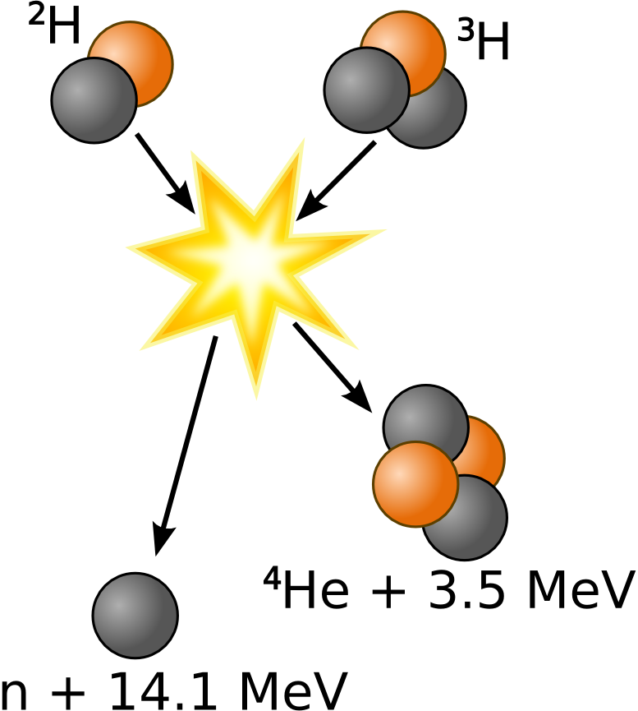 | Fusion of deuterium with tritium gives helium

Nuclear fission should have been that of thorium, 4 times more present than uranium, allowing powerplants that existed, producing 4 times less waste 100 to 10 000 times less durable for the most part. These Thorium plants were tested from the 1960s in Oak Ridge for 4 years. Molten salt reactors already existed and were less risked.

Thus the next generation plants can be stopped much more easily than currently. Thorium should have been a choice turning our countries towards peace. The only objective of the fission is to set up nuclear fusion, using hydrogen or even more easily helium-3 and deuterium, to burn the waste from nuclear fission.
Nuclear waste can in fact become stable again with the MYRRHA belgian project and the 2018 Nobel prices’ lasers. In other words, waste can return to a normal atoms. The thorium energy is the most stable known. Thorium reactors such as the mini-FUJI and an old German project can be stopped by producing less waste, even recycling waste. On 2018, Nuclear energy is used in thirds. However the remaining rest would heat cities with minimal loss. We could also charge the hydrogen or fuel cell cars. Technology now allows this.
Thorium-uranium could reuse atomic bombs, to produce energy with plutonium. Better this time it would improve nature by greening the deserts, including seawater’s desalinization, near the coast, pumping mass above the Sahara. Indeed water goes below the Sahara to go into the sea.

There is no way in any way to lower the production of energy, otherwise most clean with thorium, with MYRRHA and with the 2018 Nobel prices’ lasers. Yet the world's population can still rise to 25 billion people. Yet depopulation has begun and demographic curves are declining. Finance is creating a genocide by returning to less dense energies, therefore less useful.

The danger of plutonium

By discovering new radioactive isotopes in the 1960s, researchers have been turned up towards the production of plutonium, a waste that allows nuclear weapons, which is now useless because most of the powerful countries have it. Our policies acting like children do not understand the dangers of this power. Or they only know them after thinking about it, like Paul QUILÈS. Paul QUILÈS tells that nuclear disarmament implies active cooperation between countries, based on utopia. Larouche speaks about growth.

Energy conversion

We transform energies to other energies so we can use them. There is loss in every conversion. Nuclear power makes it possible to do that we already do, with additional possibilities. Thermal powerplant is a central using energy. We cannot go from one energy to another without loss. For example, chemicals, mechanics and nuclear power make it possible to create electricity, not in equivalent quantities. The electric energy is used again towards other energies.
Energy making and growth are intimately linked. The longest energy sources of life are uranium during 300 years, coal during 800 years in 2016, also thorium-uranium during 10 000 years, if we use it now. These energies can then be replaced by fusion. The fusion torch will recycle waste very easily.

Sources
- https://en.wikipedia.org/wiki/Thorium_fuel_cycle
- https://larouchepac.com/sites/default/files/So_You_Wish.pdf – economy book
- http://www.geowiki.fr/index.php?title=Monazite-%28Ce%29
- http://www.mindat.org/min-2752.html

My Notes
Research on thorium.

Describing Scientifically Jobs
Monday, March 10, 2014
On 2017, media and schools are trying to induce that money is a goal, while it is only a means to obtain some wealth. So someones try to pervert jobs. There are obviously jobs that are more perverse than others. At the same time, finance tell us that everyone should be honest except the stranger.

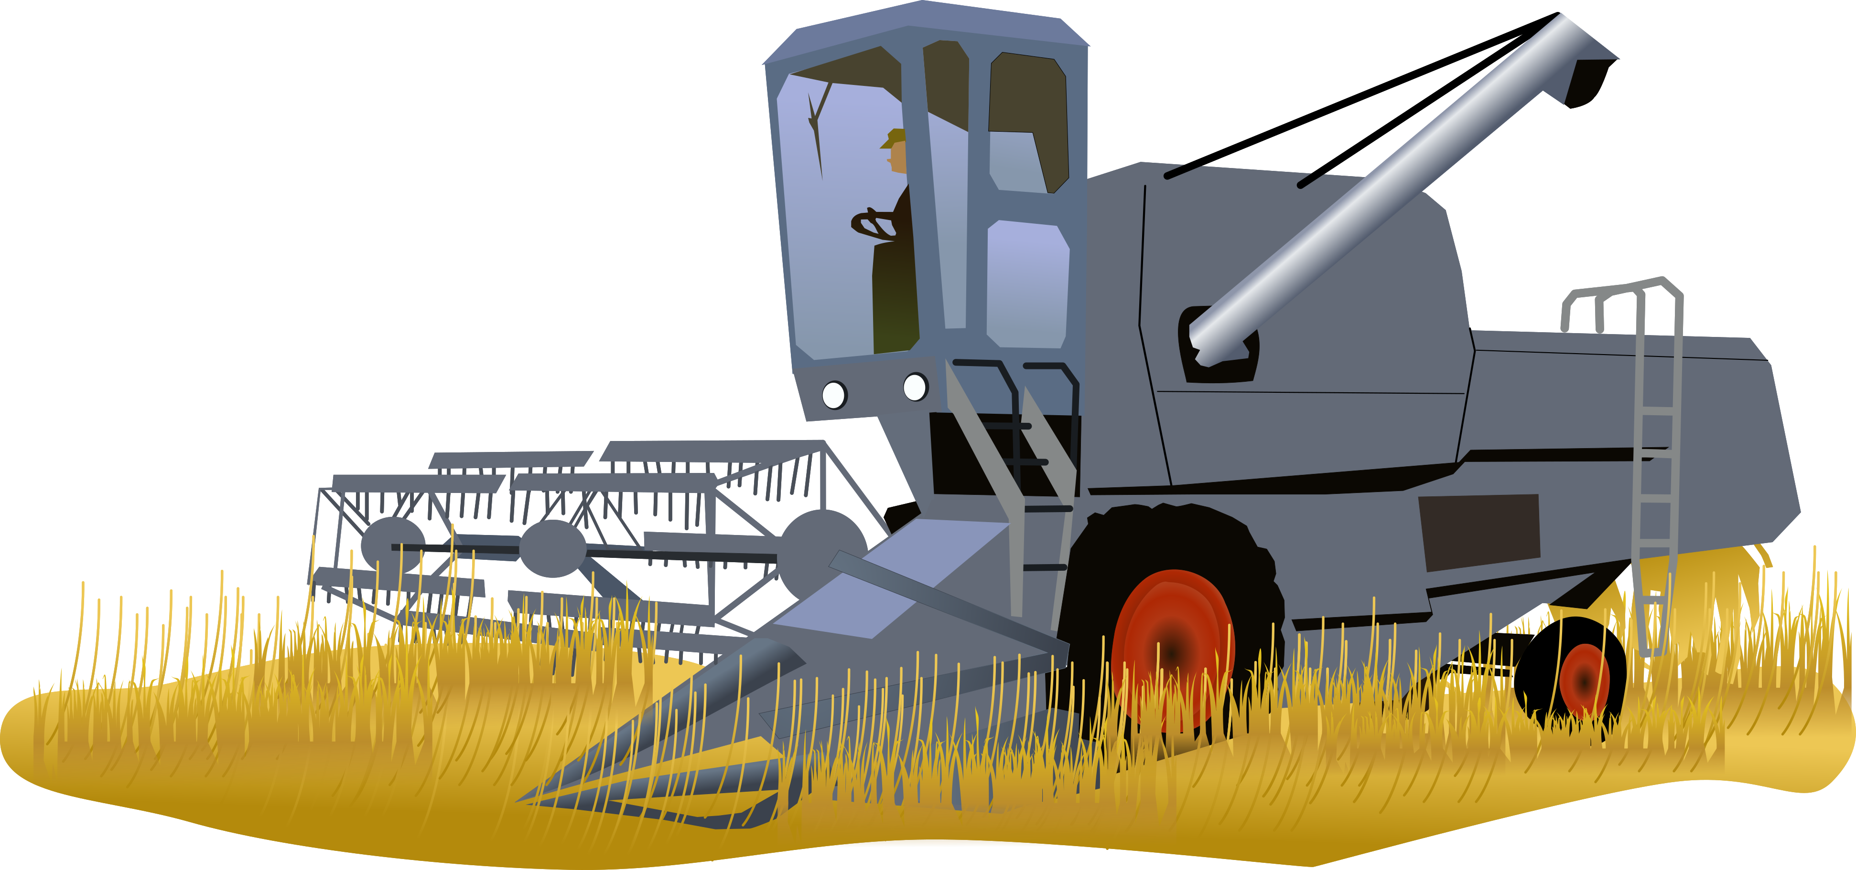
The job of farmer is noble
It is very difficult to describe scientifically the logic of our job. This tends to challenge us. I think my job as a computer’s engineer requires to purchase computers. It's because there are so many computer’s engineers in France that we are engaged to the digital world, importing computers from Asia to destroy our industries. The computer’s engineer is therefore a lawyer. But it's not just him whom does it. Here is an excerpt from the book "The Principles of Social Science" by Henry Charles Carey. The trafficker is, according to Henry Charles Carey, the one who buys cheap to sell expensive, according to the famous quality/price ratio. Here is the answer to this famous question: Why an empire ends up imploding?

"For those who live working to become owners, the commerce’s growth is not wanted, its growth being everywhere accompanied by the fall of the brilliancy and magnificence of those whom wish to lead the movements of the Society, with a view from their personal interest. The statesman profits isolating his fellows, and so does the lawyer, the trafficker, the great owner of a poorly cultivated land, and all the other individuals. belonging to the classes, whose means of existence and distinction are due to their intervention, between those whom produce the commodities and those whom need them for their consumption. All these individuals collect a temporary profit, preventing growth’s movement in the society; and the greater their power to do so, the greater the proportionate deal of the product of their work, and the weaker the deal to be shared between the workers.

The broker does not want his constituents to be able to meet and arrange their business without his intervention. The opposite is so true that, the greater the distances is between them, the more easily he can get a fortune at his expense, buying for himself at a low price and to their detriment. When prices are low, he sells for his account, more at the expense of his constituents, when prices are high. The slave owner lives by preventing the association among these individuals who belong to him, where it needs for them that they bring him the goods that they produce, and that they come to him for all that they need of use. The valet knows that the more obstacles there are between the producer and the market where he sells his products, the greater the demand for horses or cars, and the greater the proportion of food he will retain as compensation for its services. The shipowner is happy when individuals are forced to separate from one another, as was the case in the last Crimean war; or when poverty forces them to abandon their homes to emigrate to distant lands, because this state of business brings demand for ships. He is also happy when harvests are plentiful, and the quantity that needs to be transported, accumulates constantly, causing a rise in the price of freight. The real and permanent interests of all classes of individuals are one and the same; but their apparent and temporary interests are different; and that is why we see individuals and nations constantly engaged to the pursuit of the latter, to the exclusion of the former. Blinded by the idea of profit and the power of the moment, the great men of Greece and Rome took no account of this fact, that they constantly exhausted the forces of the society of which they were a part; and following in their footsteps blindly, those of Venice and Genoa, of France and Holland, of Spain and Portugal, followed a way exactly similar, always linked with the same results.

It has been the same, invariably, in relation to the trafficker, whose greatest desire has always been to maintain at its highest point, and even to increase the need for individuals to use transport and to limit even this need to use the instrument he possessed himself. The more completely this goal was reached, the more complete the centralization of power became, the more splendid were the places where exchanges were necessarily to take place, and greater the temporary prosperity of the trafficker was; but faster also was his decadence and more complete ruin. The Phoenicians and Carthaginians, the Venetians and Genoese, the Spaniards and the Portuguese, the citizens of the Hanseatic towns, and their rivals the Dutch, showed themselves ruthless at all times in their efforts to force the inhabitants of their colonies to come into their villages’ ports and to use their ships. At the same time as they sought to seize power as a means of gaining wealth, all this power was employed in order to maintain at its peak the burden imposed on other peoples, as a result of the need to effect change of place. This, moreover, gave them advantages for the purchase of the raw materials, by making them accumulate in their ports, and subjecting them, consequently, as today, to heavy loads and to considerable risks, and advantages equal for the rest of these materials, when they were manufactured and ready for consumption. Thus they enriched themselves momentarily, while they considerably impoverished everyone whom depended on their assistance, precisely, as we see it today, in relation to the individuals and companies whose trade with the unfortunate aborigines. from our western continent, with the Mexican population, with the Finns and Lapps of northern Europe, the natives of the islands of the Pacific Ocean and those of Africa.
Exhausting the peoples whom they trafficked, they found a perpetually increasing difficulty maintaining traffic, in consequence of the constant increase of famines and epidemics, such as we see so frequently in Ireland today and India. As the population dwindled, the power to maintain the roads and bridges leading to the market was diminished, either to sell the miserable produce of her land, or to purchase the commodities necessary for her consumption; Some of this business is now seen in action in Jamaica and Ireland, India and Mexico; in all these countries the variety in the products of the soil is constantly lowering, at the same time as there is a corresponding tendency to decrease in their quantity. Nowhere it is this sort of business more striking than in Turkey; It is about this country that a modern traveler said : "In every canton, the majority of the agricultural classes cultivate the same articles of product and follow the same routine of cultivation. As a result, each individual has a surplus of items that his neighbor wants to sell. This is precisely the situation in Brazil and India, Virginia and Carolina. Under such circumstances, - the power to maintain trade being nil, - the poor farmer is subjected to the "tender compassion" of the trafficker, whose power over him increases, with the diminution of the possibility to maintain relationship with one's fellow men; and from there comes that farmer is so enslaved. Such are the results which necessarily derive from this fact: the man has become an instrument used by the traffic; but that the latter does not succeed in profiting from such an injustice, is proved by the decadence and the definitive fall of societies whose prosperity was due exclusively to this same traffic. "

My notes

Explain in your way the movement of trade and traffic.

What is Appropriation?
Friday, November 7, 2014
There is no doubt that someone who enables society to grow must be rewarded to grow that society, by the fact that, instead, he really gets the goods he uses. Ownership movement is creating or losting owners. Power and liberalism allow the rulers to make the owners believe that they will be able to keep their property, without these owners being really useful to society.

If you stay in a place that you rent, it is accepted that the one who pays the place becomes the owner of the place. This is not that is observed in 2018. Indeed many owners have to borrow, so that it is the tenant who pays the loan. The tenant is not only paying for the competition with the growing number of new tenants. But he is also paying the owner's debt.

The owners want more power. Money makes it possible having power over a country. Thus the owners accept the private money because it also means disengagement from the state. Owners are made to believe that poverty is a source of wealth for them. This is taught by liberalism and the money economy, hiding the monetary creation.

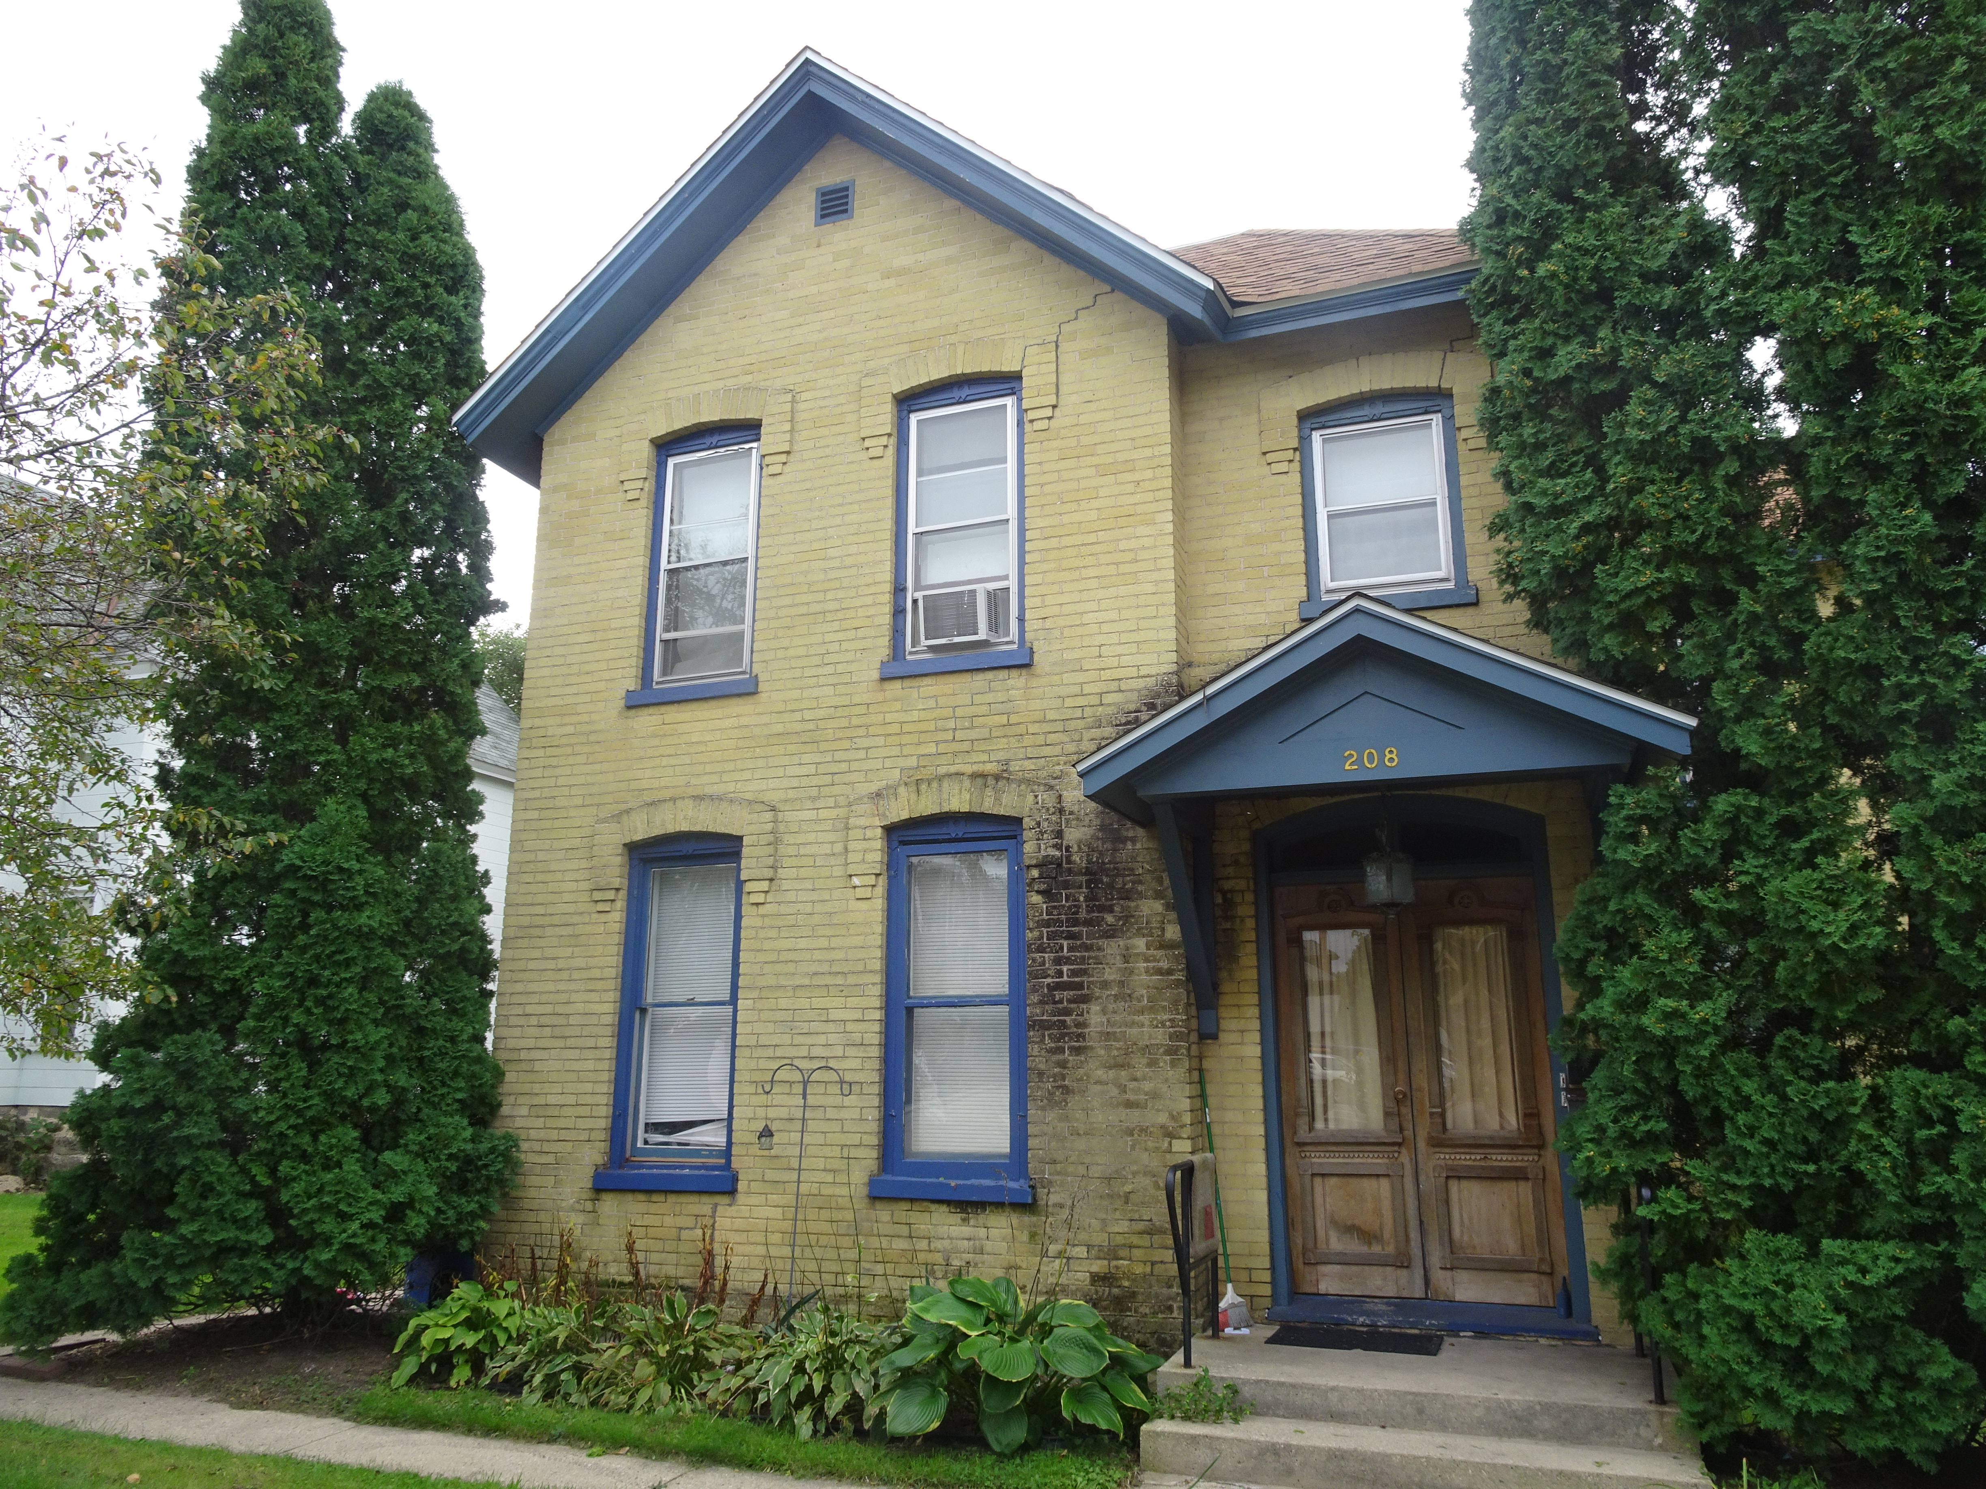
Becoming an owner in France means being bourgeois

This loss of the state allows the liberal whorehouse allowing to increase the poverty. Liberalism is a law believing that the individual makes society. In fact, individuality is created by society.
The idiotic possessed then believe that it is beneficial to himself, because the inequalities increase. It is not in any way. Indeed, the most important above everything is to dispose that we use, in order to be recognized. It's not about owning those whom create wealth. In this case we are going towards society’s loss, because there is no interest to grow society, in this case. This is pure speculation that someone else can belong to you. It is the illusion of power, the cause of revolts.

After having grown country, everyone is satisfied with the short view he has got. Indeed many are owners, because the trade and growing country allowed politically to everyone to create a useful work, this against retribution of that has been created by people. Everyone could own with the fruit of his work. So there are a lot of owners.

However liberalism will meddle. After making the school unfit, saying that the country can no longer develop, because of the private currency, people do not flourish, believing in this fear of living in a finite world. It is this fear that leads to entertainment, that is to think about something else. However, we are happy when we got answers to our questions.

Yet historically humanity has always grown, unless demographically. Many growth’s projects are waiting, especially in Africa. With the density of available energy and the canals, deserts can be turned green or swamps can be transformed into farms.

There are no finite resources, on the one hand because we are only transforming most resources except energy, on the other hand because we do not even know the universe’s limits. Finally, humanity has not only found more and more resources in the world, but these new resources are also becoming richer. Indeed, that is richest is also difficult to get in nature. For example, swamps took a long time to become fields in France, thanks to axes unless. There are still many swamps elsewhere in the world.

All of these findings are against the liberal theory of rent, saying that there were those whom came first who created wealth. Indeed commodities or products are worthless, if they can not be sold. Homeowners are worthless without the society that allows them to become like that.

All these findings are also against Malthusianism, currently called decay, saying that there are too many humans. On the other hand, the owners’ sons will want to increase their owns, like spoiled children. Some, like Prince Philip of England, will want to transform himself into a virus to kill people, for his caste to get more.
The people who believe in entertainment will believe in everything entertainment say to them, depending on that they hear around them. The polls will move towards liberalism, meaning "Enjoy because everything is fine: Markets and the stock market manage everything!". The possessed will be possessed by the desire to possess. They will also want to own others.
We will then post its culmination, Malthusianism, which consists in making believe that the resources are finished. This will be due to the science’s disinterest, because the scientific reflection of Plato has not been used. Also, alarmist sci-fi movies will drive the decline.
So the population thinks we cannot grow, so there's no reason to live anymore. Then the owners’ sons will have more wealth than they will not use. These riches will be no more rich, because are rich the ones that know that they have to do with their owns.
Only the wealthy will be more and more dispossessed, first with their companies, then with their children. Indeed, if those whom produce do not get rich, then society decreases.
The people will think about a trickery in this liberalism, even if some will flourish. Indeed, fulfillment will be censored. Will be recognized talented speakers, able to explain to you that everything is commendable if enough people accept it, according to the liberal chaos.
The truth's research leads to its fulfillment. It will be unemployment or a meeting that will cause the population to dare to question, if it seeks happiness. Some will not have abandoned the scientific thinking and the truth's research of their childhood, necessary to learn to walk and talk.

Those whose will not seek the truth, which brings happiness, those will be performers of the system, because they are unhappy themselves. The sophists, those speakers whom pervert the truth, will be rewarded. They do not know themselves, rewarded for their ignorance of liberalism, but especially for their knowledge of others.

Then the population will have little, and other countries will show that growth is beneficial, as long as this population knows it. Then the tenants will want to become owners again, not to be owned. They will accept the morals of those that they did not understand before, because they will have got enough news from those who seek the truth, but especially because this struggle growing by the common good has been sufficiently known and remembered, even if censored.

Source
- The Principles of Social Science - Henry Charles Carey

My notes
Do my parents own their home? Is this normal?

What is Trade and Traffic?
Tuesday, January 3, 2017

Trade and traffic are linked. Indeed, trade is the politics that will enrich the country. Commercial competition leads to lower prices. With this alone idea, everything would be in the best of all worlds, but that's not the case.
There is also traffic, but there is also financial competition. Traffic is about raising prices when the competitor is not there. The traffic can be canceled by the commercial competition, also by bringing together the actors between them. In this respect, the web is not the best solution because it is used as an interface for transport. The web is worthless than the train, which, if financed as much as the road, would be free and very fast. Indeed, you are learning an important economic concept, namely the work’s economy. The entire human society operates saving labor. Using one engine is better than using many scattered engines.
Financial competition comes when little enterprises have become big business. These big companies have got a lot and buy markets. They want to individualize by the car, in order to get a local market, then others. Then they increase prices. Only politics can overcome these big enterprises, cutting into several societies, according to the french antitrust law of the National Council of Resistance.
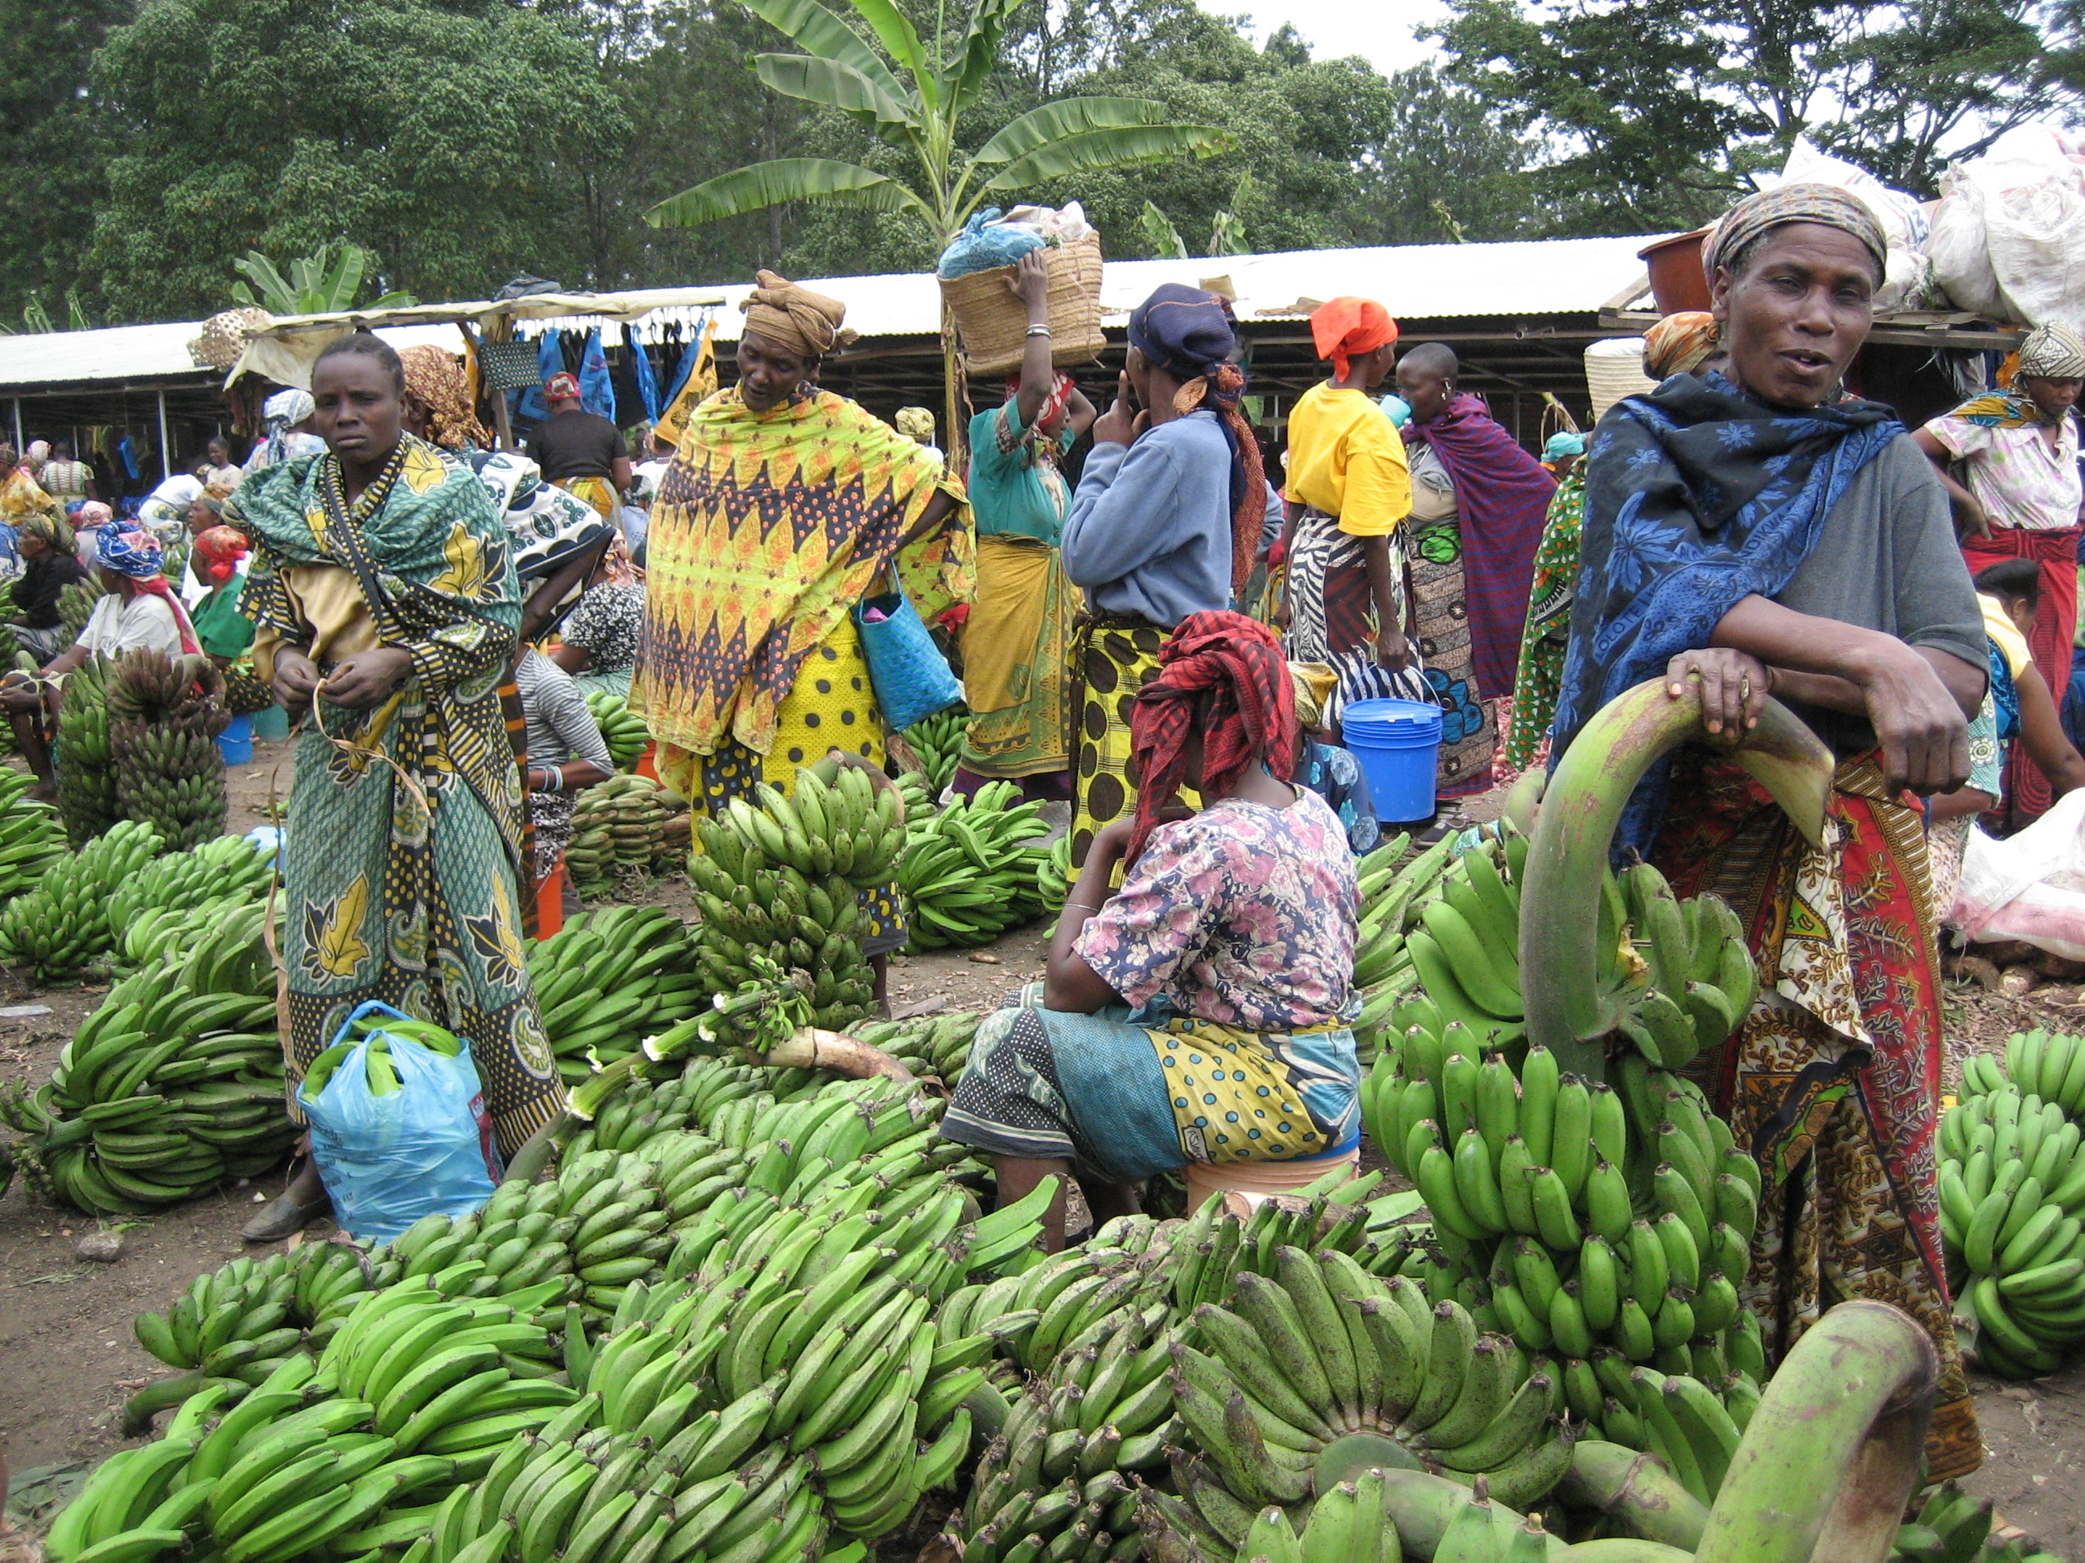
The market challenges traders
According to Henry Charles Carey, the trader uses the traffic to get rich. It's human. This trader wants to save his work easily. This is called laziness. So it is necessary to know that this traffic impoverishes the others, because the currency is a communicating vase. The ease of the trader will force him to buy the cheapest products, allowing him to sell without forcing himself. It will not necessarily respect the local products, which will be best copied by this trader. This is not illegal. The politician, elected, must be moral over everything and must ensure that external products do not harm his nation, by taxing them.

The trader will not be pushed to fault if he traffics. He will know and will even unwittingly to the state for this traffic, which allows to enrich it, because this traffic will rather enrich the big companies, its competitors. The problem of the trader will be his vanity, because he will not necessarily look at the challenge that will get his followers, who will have to find how to produce cheaper, with the poor quality products trader has to sold.

My notes
Compare the supermarket to the market.

What is Life?
Wednesday, January 4, 2017

Life organizes material. At the beginning there were the plankton then the plants, then there were the fishes, then the fishes conquered the Earth with the amphibians, then the amphibians became reptiles, to be autonomous on earth, then in the air with the dinosaurs and birds. Finally, reptiles have become mammals, warm-blooded so to go in the cold. Human is a mammal capable to improve nature with its spirit, which is the goal of the life.

Life is therefore a movement organized from atoms‘ energy. Atoms' energy will be more and more used. In fact, atoms are inert energy’s bubbles, able to organize themselves to create life, through water, which organizes earthly life. We do not know why life is organized in the universe, except to reach God, as Jesus said. If we talk about life, we can say that the universe, made up by its atoms, are creative. No living being, even twins, is the same as another. Life is the infinite choice to generate something new, which is better than before.

This snake does not like the cold
The human economy, in its essence, is made like life has grown. The human economy is creating more and more energy to do more and more things. So, with fire, which is biomass’ energy, we keep the food longer. With the energy of the sun and water, we have created the first wind and water mills, to create the automated work. With coal, we have created the first trains, which allowed a global trading’s growth. With oil, we have created great works, large dams. All these works should be accomplished today with nuclear power plants. Safe power plants and recycling nuclear waste exist. Nuclear power makes it possible to green deserts with thorium. Nuclear fusion will allow journeys to Mars and deep space. So mankind will come out of its hold, the Earth.

My notes
Why does life organize the material?

The Paradigm Shift
Wednesday, January 4, 2017

Science permits to understand nature and life. Searching on the infinite makes it possible to create paradigm shifts. The nuclear paradigm shift has finally been initiated in the 21st century by China. When the paradigm shift is under way on 2018, we are talking about the potential for relative population density, that is to say the way for the population to grow and multiply. In fact, there is still potential for relative population density. In other words, the human has the skill to grow and multiply indefinitely, on Earth, then in the universe.

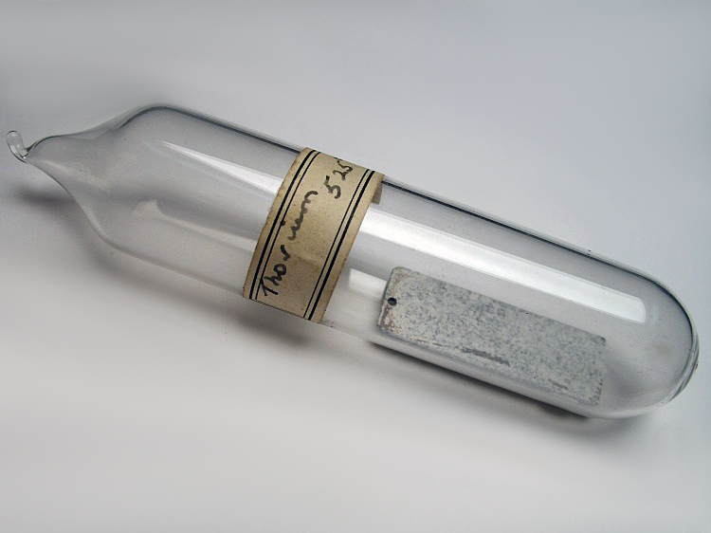
Thorium allows energy for 10000 years

To change the paradigm, it’s necessary that 5% of the population militates for this change. These people must understand that the creativity of the human allows unlimited energy to grow each others. It's about understanding the life like infinity. It is therefore essential to tell to others changing the paradigm. If not, we can talk about the USSR which imploded under Gorbachev.

Reading
https://en.wikipedia.org/wiki/De_Docta_Ignorantia

My Notes
Who really wants growing ? This is a truth's research.

Organizing: The negentropy
Thursday, January 5, 2017

Chance for mankind to organize material, like the life’s will to organize material, is called negentropy. Entropy, that is to say the tendency to disorganization, occurs when the human does not sufficiently understand its possibilities and is disorganized, by the fact that he no longer needs to meditate, thanks to the paradigm shift, who brought profusion. Thus, instead of having a continuous growth, mankind faces a decrease, due to laziness or censorship. Indeed, those who have the power need scarcity to have a grip on people. The profusion makes it possible to allow newcomers to assert themselves. Leaders do not want that.
The trend towards organization will then be used to research up. It is the only prospective job. Indeed, finding something new is the only thing robots can not do. A robot does not grow up, but learns that is already known. The robot does not have a soul. It's a machine. Our soul makes us grow. So when we make a lot of assumptions, a higher assumption comes from all of our knowledge, whether true or not.
Eliminating the mistakes of those whom have found, as Larouche does, permits to become sufficiently rebellious and scientific to be able to find. Also, the negentropy is born from the Kelvin’s entropy. Nicolas Leonard Sadi Carnot is the writer whom Kelvin bases himself. Sadi Carnot speaks wonderfully of thermodynamics. You can read the beginning of the book, to read it again, during your scientific studies.

Sadi Carnot

Reading
https://en.wikisource.org/wiki/Reflections_on_the_Motive_Power_of_Heat

My Notes
Why does the universe create?

Disorganizing: The Empire
Thursday, January 5, 2017
Every child grows himself with a certain way. This is called multiple intellects. Reading books about what makes a child intelligent is not about separating, but diversifying. Thus the school, which separates, asks the pupil to organize, but the pupil must know that he has to do that. In other words, separating without linking at school brings entropy, if the child does not rise by organizing himself. The school has done a big fault. It prepares to create entropy, disorganization, to satisfy those who have got the power.
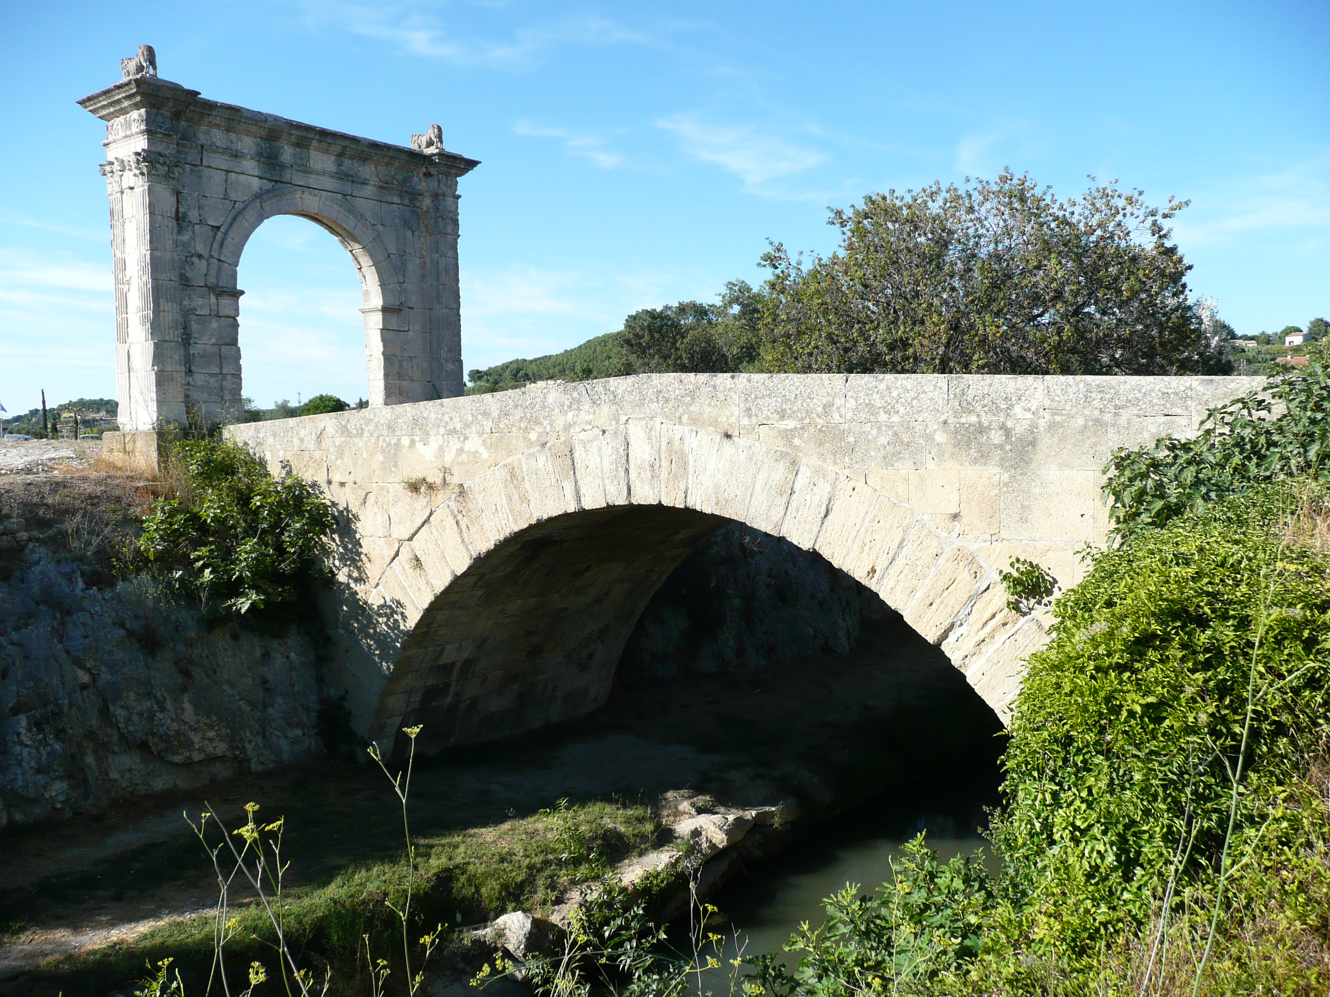
The Roman Empire was corrupted by the centralization of the currency
It's hard to tie faith to reason when you're in school. Faith is the will. The reason is to be in the truth. Nevertheless, while understanding the words’ meaning, with the Latin and the Greek, we guess a lot. A word is a secret, if you know the secret of words, at least with Greek or Latin, we can guess in college and high school, when the liberal brothel settles more and more.
When there is a paradigm shift, a new organization is needed in countries organizing a new society. The entropic countries go to war because they want to profit only from what already exists, among others. Indeed, those whom have got the power use lobbies to prevent societies to grow up, empeaching newcomers. Thus a rich country that is disorganized, especially by the school, will become an empire, that is to say that it will use its power to take the poor countries’s resources. At the end, the empire will implode or be replaced.

My notes
Do you want that your neighbor has got? Can you do otherwise?

What is Ideology?
Thursday January 5th

Ideology is the way, for those who have the power, finance in 2016, to hide the truth to people by censorship. Censorship is certainly removing sentences, but it is also transmitting false ideas, with ideology. Once words or theories have been hidden, like physical economy, the ideology closes the hole created, leading the truth’s research to false goals.
An ideology is the monetary economy. This ideology creates indicators, to make believe that all is well in the best of the worlds. Another is transhumanism. Rarity dogmas are taught to scientists to create theories. The money economy makes believe to money’s God. For those who do not believe in money’s God, transhumanism indicates that man can do better than God. That is wrong. We can equal, but we do not surpass God, because we do not know how bodies can be animated and can evolve.

We do not know why there is life instead from Jesus, who only tells us that the human, if we respects the God’s rules, will join God in his universe. It seems that God has got all the knowledge, moreover, in his universe. Indeed, how could he create life differently? God just does not want to be alone creating the universe. Indeed the universe is created more and more, according to statistics about stars of NASA.

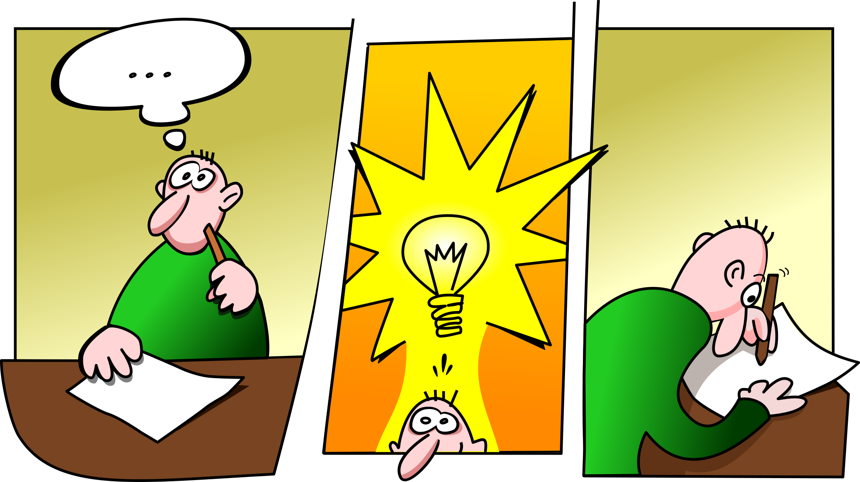
We know after if an idea is good

My notes

What is the difference between idea and ideology?

What is Liberalism?
Friday, January 6th

Liberalism is an ideology and a doctrine. It is a set of ideas and a set of life’s habits. Its goal is so hidden. The goal of liberalism is to make people believe that the individual makes society, whereas, in fact, our individuality comes from our parents, and therefore from society.

Liberalism leads to stupidity, even violence, because the individual should become afraid of others. In fact, with liberalism, the individual no longer grows his spirit because he no longer trusts in society. If we do not grow, we regress, because memory then forgets.

Thus individual has an egocentric vision and acts as a consumer having money as God or trusting any liberal ideology, like Marxism, monetary economism, Malthusianism, rent, feminism, egalitarianism.

To get out of this egocentrism, it is about finding those who see human creativity leading to human growth.

My notes

What can you learn from society?

Money and market economy

The money and market economy can be explained simply. A market vendor who sells his products alone will want to raise prices, because he is alone to sell them, thus making a profit according to the monetary economy. The trade defined by Plato will allow finance, those who possess the creation of money, to catch the merchant's capital with his isolation.
It would certainly be worse without money, since one would have to become a slave to obtain a good.
An industrialist would be less tempted to raise prices. In fact, if he knows history, he knows that he is not alone to get rich. Also, he is focused on to create of his products, so the money is used to create projects through policy. Thus, it is possible that the industrialist will be satisfied with happiness when he sells, if he is not in a money and market economy.

My Notes

Define how isolated your society and its individuals are, using dialogue.
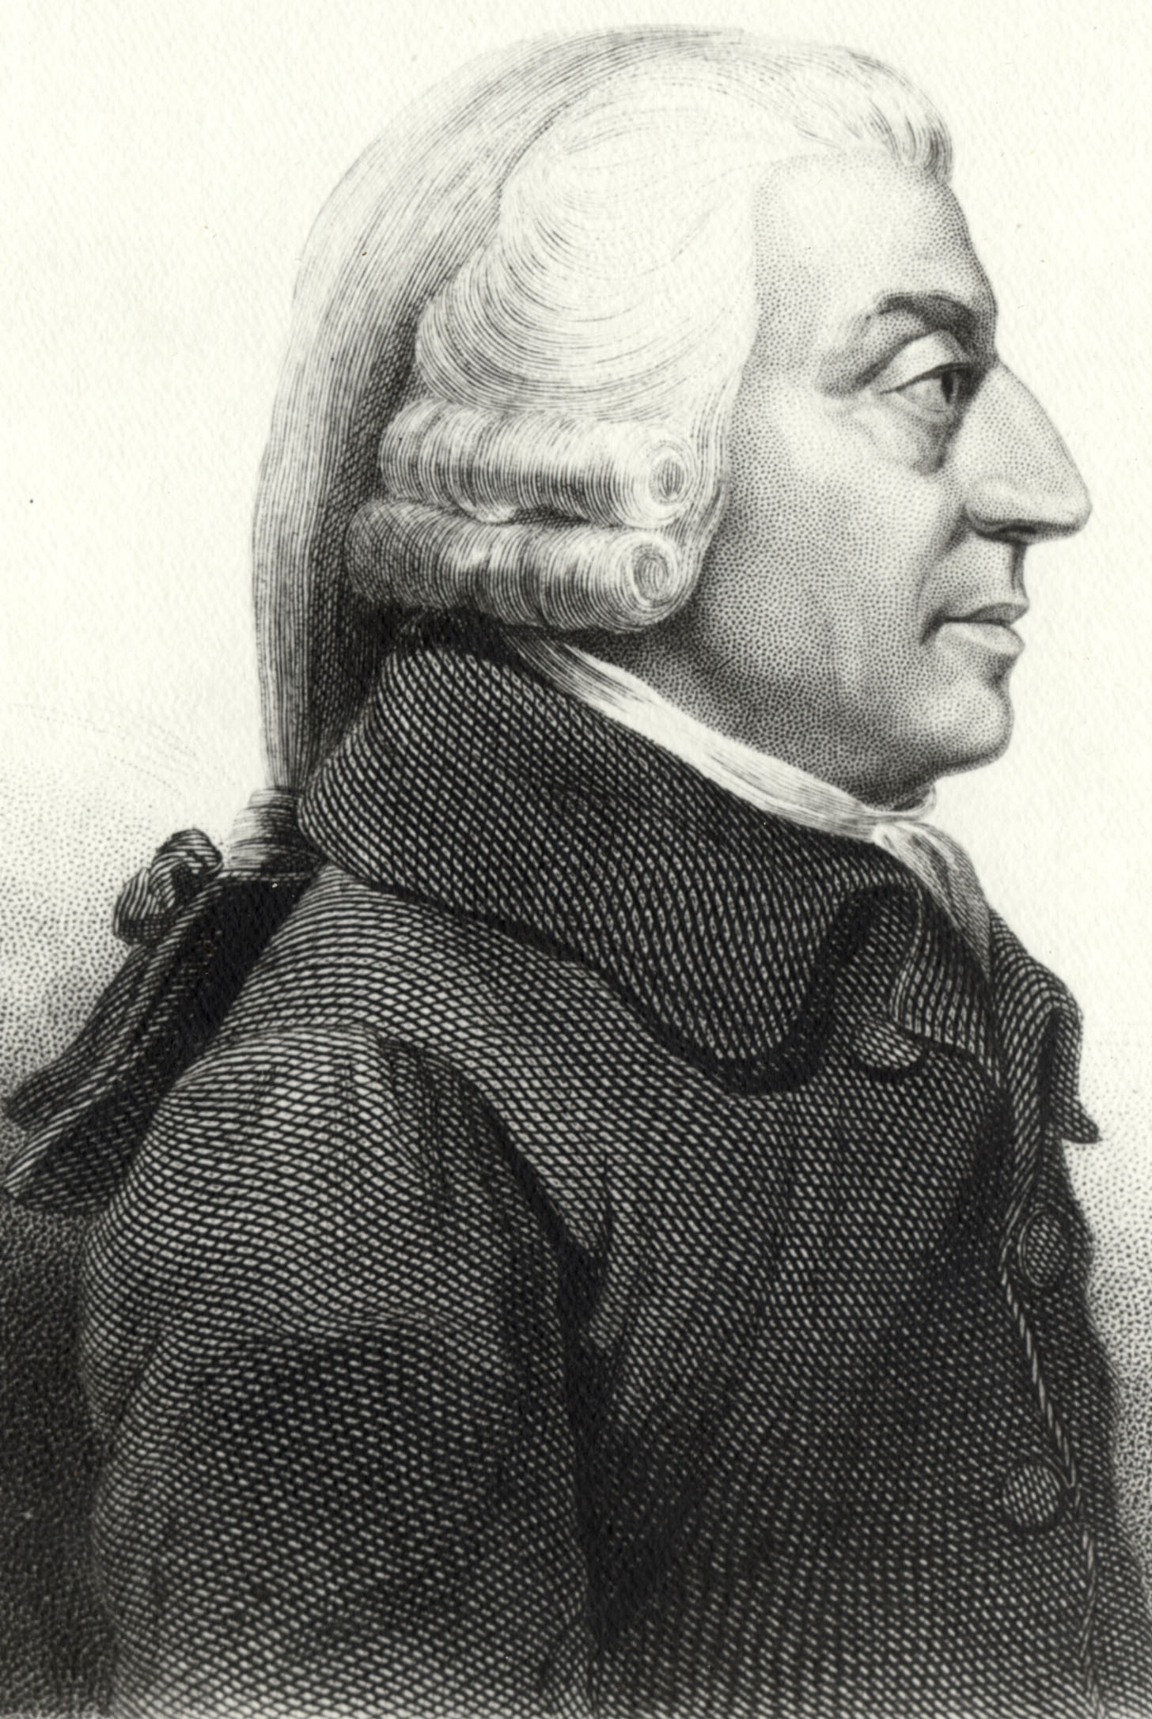
Adam Smith is viewed as monetary ideology leader

Improving Society

Scientific Brainstorming and Dialogue
2015
We are taught a lot to dissociate. But we can do many more things linking. Scientific brainstorming and philosophy make it possible to link ideas, which are hypotheses coming from experiences. It allows to sublime our creativity.
Our mind, when someone asks oneself a question, remembers it. Then it seeks, itself, a solution, with dreams and meditation. Meditation allows, with music, which allows you to think to act, creates constructive dreams. The question asked then leads to hypotheses to verify. It is important to write your hypotheses in order to better ask them later. Through dialogue we will find answers that can lead to other hypotheses.

The philosophical dialogue will make it possible to verify hypotheses linking ideas. Dialogue, discovering oneself through politics, then makes it possible to reach an agreement, thanks to science. One can value one science rather than another. But we must then demonstrate this science, as we understand it.

You tell me then that there are too many assumptions under your mind. No, we can find a higher hypothesis that includes a set of hypotheses previously found. This higher hypothesis can then create passion, that is to say a work dedicated to this superior hypothesis, galvanized by our truth’s research.

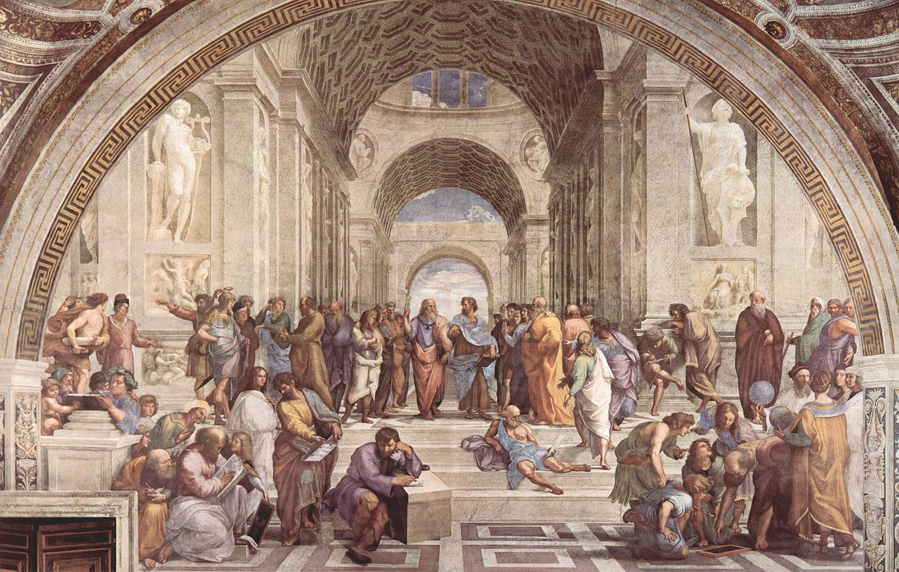
The Athens School with Plato
Higher hypotheses entrust our subjectivity. We can then understand a part of our subjectivity scientifically, in order to solve some of our faults. With our family’s story, we will understand that could have happend to us. Then, His or her partner can warn us about this delicate future.
The higher hypothesis will then ask us to use a science’s axiom, a verification in nature or in the universe. Indeed, the only way to be sure of your ideas is to use science, which allows you to erase random choices. If we refer to science to grow up projects, we can hardly be asked oneself, because science makes it possible to understand nature and the universe. Science allows you to choose wisely.
Meditation will allow us to use our unconscious, if our mind gargles with reason. So the mind can think scientifically during a dialogue.
Our found axiom can then challenge other axioms. It is therefore necessary to use dialogue and experiences to find other research’s ways. One becomes then a true researcher, able to write a scientific step. We dialogue to find new experiences. One turns one's truth's research into a search for scientific truth. Our hypotheses become articles, thanks to reading about mankind limits.
Our truth’s research makes us understanding human limits. It is, then, interesting to create a culture, to improve one or more mankind limits. This makes it possible to become a rousing researcher, galvanized by filling a poorly explored human’s way.

My notes
Begin to link ideas, asking you to meditate, philosophize, dialogue with others.

Use ideas’ linking for your projects. Grow yourself with an activity, to convince.
Try to answer the assumptions that are made through dialogue and meditation.

Doing Politics
Friday January 6th
A veritable scientist does politics. Making politics is to convince to realize projects, their owns or others.
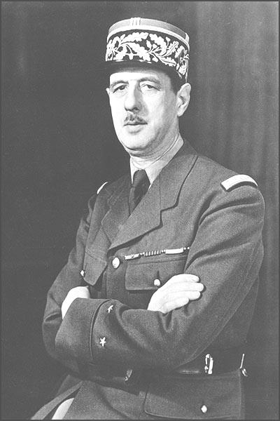 | De Gaulle, politicizing ended up himself to find best ideas
To convince you must know how to meditate and philosophize. This allows to create a higher hypothesis. It is the option to convince easier, through dialogue, linking knowledge. This requires contradicting scientific authors, as did Einstein with Newton.

Indeed, some scientific authors follow a lineage of other authors. Empiricist scientists, that is, those who trust what they see, to achieve what their direction wants, can not find anything new. Indeed, scientific discoveries must go through the test, the hypothesis, the experience, searching for scientific truth. After searching for his own truth, this becomes the truth, as one goes along.

If a scientist really does that he wants, he has to make politics. The logic is the same as for the paradigm shift. Einstein had made politics. This allowed him to achieve that he wanted. His nationality’s variations were only political trials, given to countries that did not support his ideas.

Readings

Read some of Einstein's books, the most accessible.

My notes

Write up your project. Try to convince others to do them. Make a balance sheet and grow up.

Becoming a Citizen
Friday, January 6, 2017
Engaging yourself onto the life of your neighborhood allows you to start making politics. Starting with a constructive activity, like model making, a puzzle, initiates to build.
So, in the street, we try to find out how buildings and roads are designed. Roads and buildings must comply with rules of access or flow. We are interested in architecture, in order to build any project.

Once ideas come to improve our environment, we engage us to the life of our neighborhood. We think daily about architecture and economy of his neighborhood.

My notes

Think and talk about your neighborhood.
Develop your project. Try to convince others to do it. Make a balance sheet and grow up.

Being Right
Friday, January 7, 2017
The one who is right, in the moral sense of the word, is the one who has the vision on the longer view. To have a long view, it is about using and defending general interest.

The general interest is the collective interest, which even allows to create new rights for individuals. When we defend the general interest, we highlight these new rights, which must be guessed, by scientific growths, or even paradigm shifts.
The games‘ theory is to anticipate the contender to find better than him. It is necessary, with game theory, to spy on the contender. The scientific defense of the general interest and politics make it possible to dispense of games’ theory. One does, then, only inquire about the contender.

My notes
Do you think you're often right?

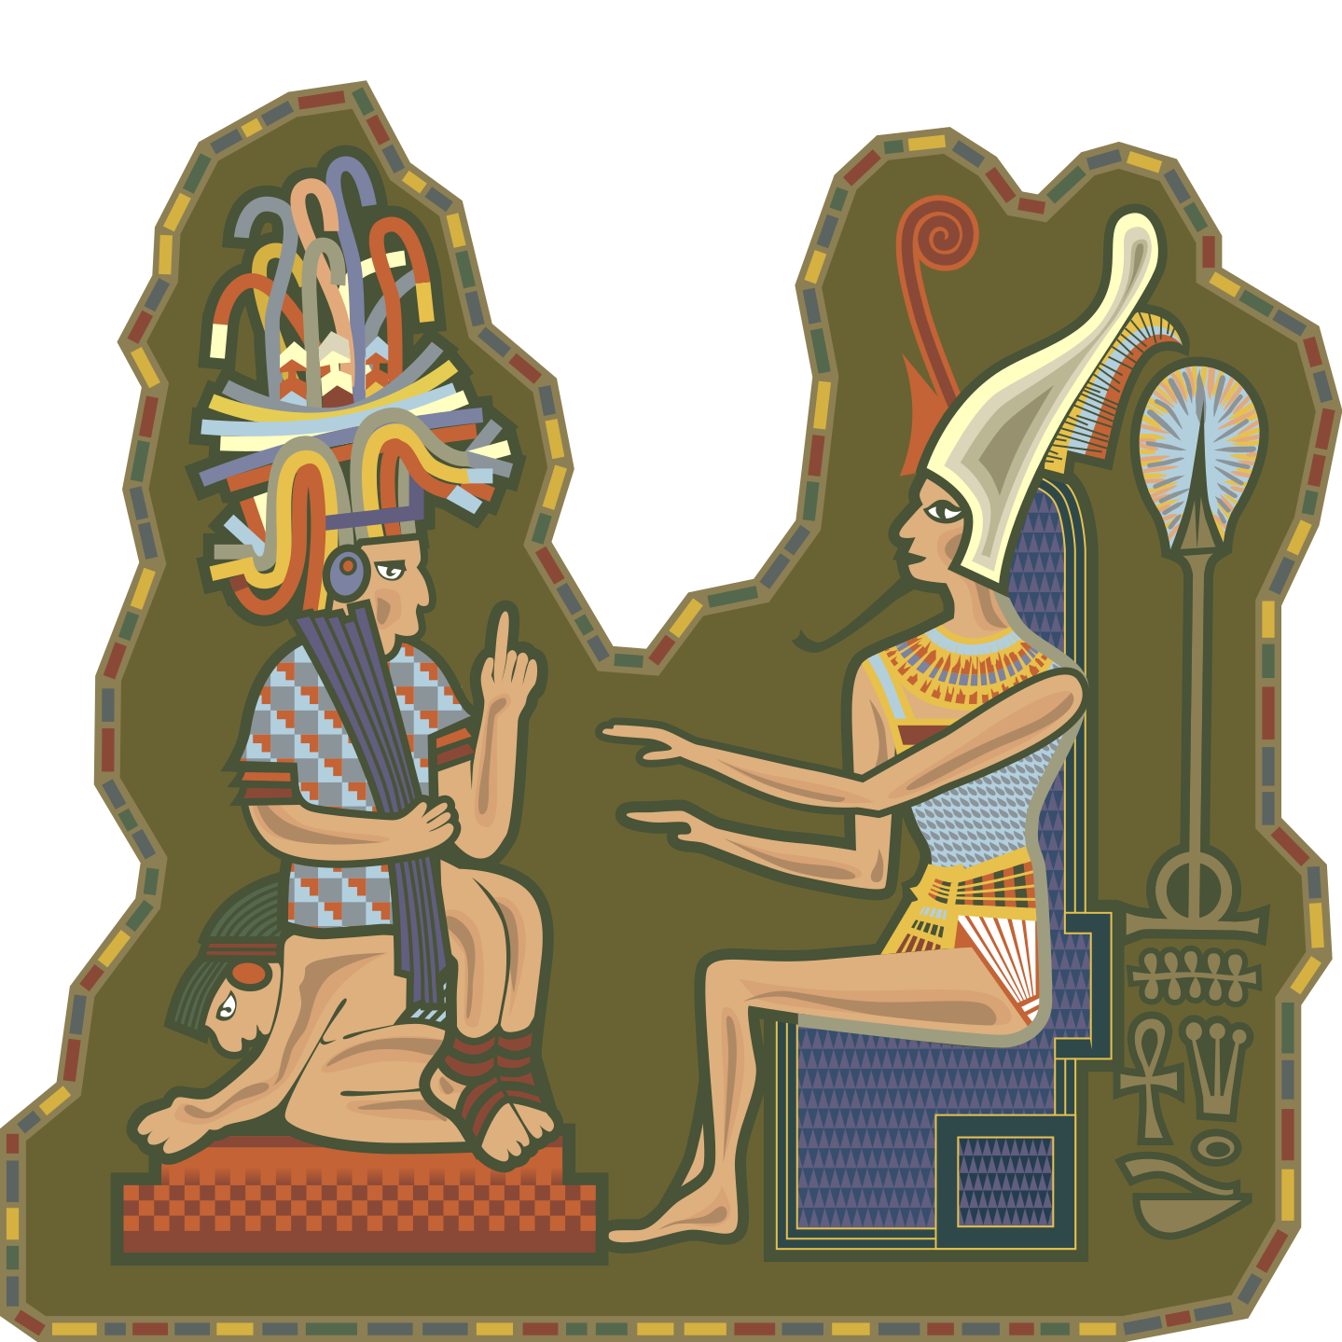
A chief wants the good way

Creative Like the Universe
Saturday, May 11, 2013
Life exists because the universe that we know can create life. Life is an universe’s creation, so NASA discovered that there are more and more galaxies especially among the smaller ones. The universe is spreading and organizing itself, because large galaxies create instability in the universe. Large stars have a short life and easily create black holes.
If you meet scientists, some will tell you that the universe is going towards a death where there is no more energy, whereas, nevertheless, it is possible to generate energy with any atom, according to Einstein. If we have a look at science’s history, we realize that even Pasteur, scientist deeply believing in the human, did not believe sufficiently in the creative universe’s capacities. He had forgotten that he was a creation of the universe.
The French entropic standard is based on a quotation from Lavoisier: "Nothing is lost, nothing is created, everything is transformed". This dogma, still learned at school, can be easily gainsaid: If nothing is created how can something exists? So we know that if there was no more energy at all, the atoms should not move. But it is very difficult to make static atoms by bringing them to 0° Kelvin. So we would be in a universe without energy, where energy should act.
The entropic way consists to say that the universe is chaos, organized with transformation’s laws, which brought life luckily. Yet scientists tell you that the probability to create life luckily does not stand up. It's as if human had made his discoveries like Newton, with an apple upon his head. Yet he copied Kepler. Many scientists are mistaken while trusting their senses. Yet, with the abstraction capabilities of the mind, one can rise through experiences and assumptions.
To be a good scientist, you have to be political and involved. This makes it possible not to be focused with others. One then use truth’s research, which demands to find answers, consciously or unconsciously. Many bad scientists are capturing finance budgets because finance wants to show that resources are becoming scarce. Thus they hide the discovery of thorium, abundant energy, very stable and ecological, thanks to the belgian MYRRHA project and the 2018 Nobel prices’ lasers. Unless someones make the people believe that we will run out of energy. These results makes ourselves pessimistic to better slaves ourselves. Someone whom believes that man can not grow, is a potential finance’s follower, because he will not even rebel, believing about natural animal picking, also promoted by finance. For example, we see this eugenics in Le Monde newspaper on 2012.
Now, our creative reason should be transmitted through education. Indeed, it identifies us against the animal. It also allows us the work‘s economy, to raise us like scientists. Scientific brainstorming consists to verify hypotheses, through the truth’s research, to grow with general interest, according to Confucius.

My notes

Why is the universe growing ?

What is Energy?
Thursday January 5th

Energy is work. We feel the energy with its heat. Energy is measured with Joules. The physical economy is also measured with work, with Joules. The work done by a human, or a robot, consumes energy. An atom is inert energy, not creating work outside a body, yet able to organize itself in our body, to help us work.

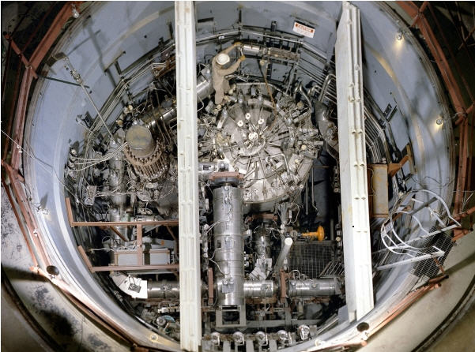
The first thorium reactor is from the 1950s
Energy is not fully understood. Indeed, NASA discovered that there were statistically more and more stars in the universe, including big ones, proving that the universe creates not only life, but also energy. However, Kelvin falsified the work of Nicolas Leonard Sadi Carnot, to believe that there should be less and less energy. Kelvin is always learnt. Nicolas Leonard Sadi Carnot is known outside France.
Knowing that energy creates work, the more we will compress energy in one point, the more we can do different jobs. We could not create a train with wood, called biomass energy, but with coal, called carbon energy. We can not create complex mechanics with coal, but with gasoline, called petroleum energy. We can not go to hypersonic speed with gasoline, but with nuclear fission, called nuclear energy. Denser is the energy, less it will emit waste. Thus, low-density nuclear fission creates much more waste than dense nuclear fission. Dense nuclear fission can also recycle waste from previous plants.

My notes

Write about the beginning of Nicolas Leonard Sadi Carnot's book.

What is Money?
Thursday January 5th

You will find many economy’s measures using currency, with the money’s economy. You should know that the currency has no productive value on 2018, that is to say that it has only a fiduciary value, which is a belief value. It is about transforming money into work, into Joules, to have a reliable comparison’s basis between countries’ economies. So we realize that countries, that do not own their money, are richer than those whose own the country’s currency want to show it.

The Euro does not belong to the Europeans on 2018, but to finance, just as the franc’s countries do not own their CFA franc, belonging to the French Bank. France only has to create francs to pay the countries of the CFA Franc, just like the private banks have only to create private money, so that our states pay them interest, increasing price to more than 40% of the original work. Then the work becomes scarce. Then the money wins in fiduciary value.


We can be baited by papers
Money is used to lead to a goal. The currency makes it possible to obtain a good quickly, if the purchase is made possible by a state bank or a private bank. A very important part of the European currency is created by private banks. The notes are created by the European Central Bank. But loans create money too. So indebtedness must repay more than that was created. It does not make sense. This is also why the ECB has given a lot of banknotes to give them their result, so that they flee into tax havens, to create wars, allowing them power and scarcity.
A bank must check if the conditions are met to be able to pay. In this case, it must provide the money requested. If these conditions are not met, the state and its justice must intervene, to settle the dispute, always for the indebted, if his speech is true. That's not that happened on 2018.

My Notes

Try to write about creating money.

Confederation
Wednesday, October 6, 2021

The confederation makes it possible to transform different castes into a united nation. The confederation’s head is used to unite the different castes proposing one or more opportunities for consensus towards the castes.

But consensus makes it possible to grow. Everyone loses and everyone wins. So the confederation is getting stronger with diversity. If all countries are organized into confederations or nation-states, we have an ideal world united to go into space.

My Notes

Write with political books from the Tamery Sematawy Maat bookstore.

Planning

Planning a country, in order to achieve industrial and infrastructure objectives, was used during the First World War to lead the war effort. However, planning is mainly used to achieve the desired development goals. To go to war, it is necessary to industrialize. Thus planning was used during the New Deal to allow United States to reach its current standard of living.

First, engineering and research schools were created. Then engineers and researchers were placed in key positions to achieve the objectives consisting to grow industry for infrastructure and given objectives, such as space or social security.

The industrialists allow them to know how we get the objectives. They are a complement to engineers and researchers indeed devoid of interest’s conflicts. Engineers have learned how to set up politics to achieve their field’s goals. Researchers have a long-term vision to anticipate the chosen objectives.

Planning dictates keeping the currency public. Finance has chosen not to go against the public currency during the planning period.

My Notes

Create a project to industrialize your country.

Knowing to Grow a Nation
Friday, January 6th

To know how to grow a Nation, we must first check if the conditions are fulfilled to grow it. Then we reduce the Nation to a gigantic industrial enterprise.

First of all, if there is a debt, we have to check the legitimacy of the debt. If the debt really belongs to countries, not to private banks, it is about verifying whether the country has lent the money with the intention to help repayment. Otherwise, the debt can be canceled.
If the debt belongs to the banks, it is about ordering the banks. We put in place the transparency of the banks. Deposits are separated from speculation. It's called a Glass-Steagall, set up under Roosevelt and under De Gaulle. So financial banks go bankrupt. We then negotiate the debt with lawsuits against the banks. So there is no more debt to many banks in his country.

Then we create a public productive money. So we create a national public bank, which creates public money, according to future industrial projects. This goes from industries, through the inevitable agriculture, to major works, to promote industries and agriculture.
To check if there is a real economy of work in his Nation, we reduce our nation to a gigantic agricultural and industrial enterprise. Services must not grow faster than industries, otherwise it can weigh down industries. Services must help industries and agriculture. GDP does not contain services or traffic. The unit of measure is the Joule or the Watt, which is the working power, in other words Joules in unit of time.

Agriculture is a priority. Public money goes first to agriculture. Industries must help agriculture.

My Notes
Try to grow your country with this chapter of the Larouche-Riemann method:
- https://larouchepac.com/sites/default/files/So_You_Wish.pdf

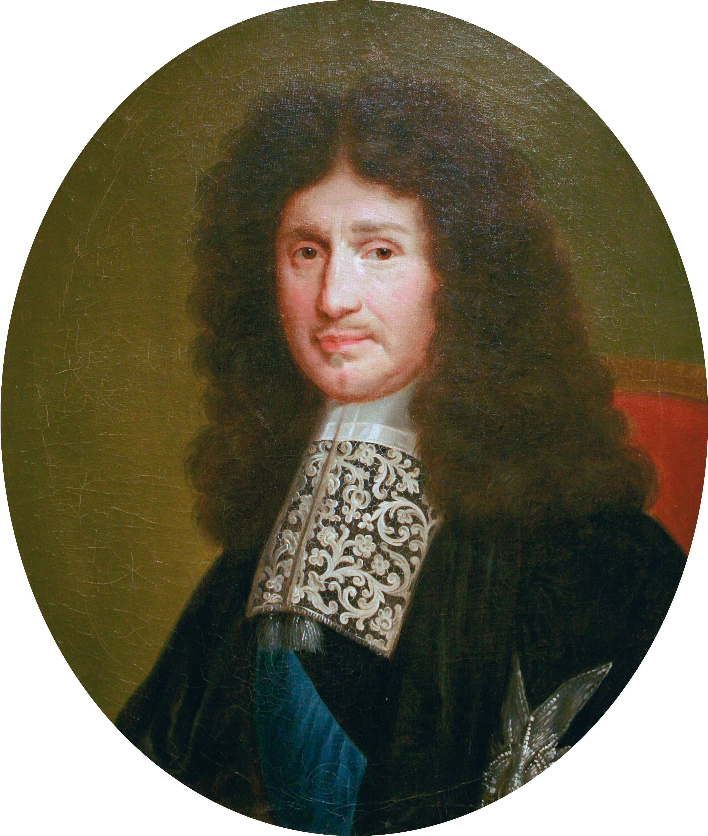
Colbert XVIe

Growth’s Combination
Wednesday, February 15
When society grows itself, thanks to a public currency, we can grow society through pooling. Indeed, when society grows, the human is able to associate others, to create corporations that grow the country.

When the traffic is minor, when the currency belongs to the State, the human wants to participate even more to glory. After the Second World War, social security was set up by the people through pooling. Under Colbert, in democratic Greece, in the Roman republic, corporations were created and enriched these countries. Indeed a corporation allows, if the people decide within them, to pool the resources to use them, to specialize each human for the community. So linking is even more present in the country.
Only when the traffic settles, we search with the short view. So the agreement is no longer cordial. Thus the state must fight against the traffic and prevent any wear of money. It is the wear and money’s tear that creates the traffic, because the wear benefits to the richest. So real estate is gaining value because the richests place their money.
Also the traffic is a view to the short term. Indeed, it impeaches the association so that price differences grow. It's easy money. The state must therefore fight against any form of prices differences’ increase, by the association or an anti-trust law, which prevents everything from returning to the same person. So you need financial transparency to know who is doing what.

My Notes
Find associations and corporations in your neighborhood.
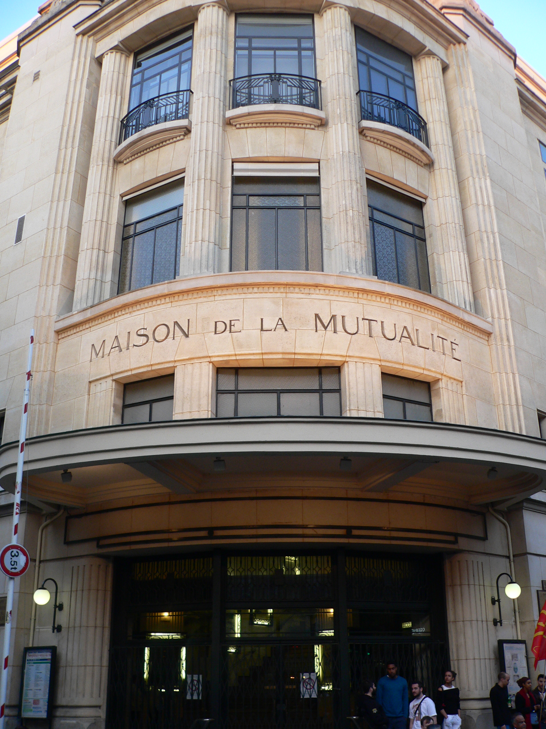
France keeps the way of Colbertist pooling
Photo by David Monniaux CC by SA

Grow the World

It is possible to unite countries, after a new Bretton Woods, around global infrastructure projects. It is thus possible to create railway tracks.
The rain is very present on the poles and at the equator. It is therefore possible to redirect great rivers’ part to the deserts. China thus wants to revitalize Lake Chad. Creating large channels is the NAWAPA project.
The rain thus created will spread over the deserts becoming fields. China has thus greened the deserts around it to prevent sandstorms from reaching China.
We can also transform marshes into fields with canals. Thus, a 200 km canal is 8 km short to feed all Africa in South Sudan.
Dams allow to regulate rivers while creating energy. Ethiopia built a dam in the Nile, requesting cooperation with the country located below the dam.
We can unite as Nation-states with China and Russia to create these great canal projects in order to be even more numerous on Earth.

My Notes

Find out about the large rivers’ flow at the equator and at the poles. Find out more about NAWAPA project.

Ideal Society

Industries produce in country thanks to a national public currency. They are protected from other countries with protectionism. They export thanks to an international peace’s policy through growth.
After promoting industries, we use them and support them promoting creativity. A national video platform and its social network are created and allow to get control of personal data. Companies see how to pay vlogs. Authors use creativity in order to produce.
The international goal is to create a MHD nuclear spacecraft that allows you to go to Mars. It is about allowing other countries to have industries and a national public currency, so that all countries move towards space.

My Notes

What would you like to do later?

Synthesis
Economy as Social Growing Science

Definitions

Capital
Our Capital is the Earth. Chinese, Russians, Indians, Brazilians and South Africans access to Capital Moon and Mars. We can get Capital March only weakly.
We must use at the maximum the space using it for our survival and for our future.

Resource
A resource is material used by humans through science, which consists to understand nature. The resource that allows us to use others is energy, knowing that we can do more and more things thanks to energy’s density.

The value
The book "Robinson Crusoe" is transformed into a Common Good, looking for the meaning of the word Value.
We learn in this book that Value is due to resistance trying to obtain something.
The sophists whom want to create Value, with a monetary objective of course, are saying that it creates poverty.

To be rich
We define the chief of an enterprise positively as being the one whom historically allows us to favor the Association in our Society.
To be rich is to be useful. But it's above everything the ability to know how to use that you have got.

Money
Money is seen as the power of the money. This power consists to favorize the Association through Appropriation.
Brazil and the 30 glorious ones define the capacity to a country to become rich, having on money a Productive and Public Power, therefore lead by Citizens. This is Money Making, defining the Money as useful.

Trade
Trade is understood by many as the ability to create wealth in order to be paid for that.
Trade grows economizing Work and Association. The Glorious 30’s Industries organized their own Trade by Train.

The General Interest
The General Interest is a consistent set of Individual Interests. It even allows to create new Rights, while Philosophizing about the Common Good.
Machiavelli succeeded to explain General Interest, awakening Citizenship by the Common Good.

Traffic
Traffic is the power to individualize trades. So it increases prices and intermediaries. It decreases on production, by the Quality / Price Report.
Trafficking impoverishes Earth and transforms Humans into Human Resources.

The Human Society
The Human Society has historically linked more and more elements with each others, thanks to and for the Work’s Saving.
At the beginning, Human Economy was using biomass. Fire permitted to keep food longer. Thorium permits to green the deserts.

Social Security Story

Social Security, allowed by the Labor Economy, comes down from the Public Profit of some French’s kings.
In the nineteenth, The Guise’s Familistery created the first Corporate Social Insurance.
The handicapped of the two wars influenced frenchies to become citizens, to defend the Social Security law, determined by the National Resistance‘s Council.

Colbertism

Colbertism, under Louis XIV and a little after Louis XVI, was one of the French works that helped to promote linking creating wealth, after a financial household.
It is more important to create wealth than to find a job. The brilliant technician is the recent and historic French wealth.
The French Revolution took place before 1789.

The paradox

It is easy to contradict monetary liberalism.
Liberalism settles because it individualizes the individual. To arrive at this goal, this Doctrine makes believe that the individual does the Society.
But it is the Society that makes the Individual. Our Individuality was created by our education. We understand each other from our Sociability, our Politics, then our Citizenship.

The Game Theory

We can believe that the Game Theory is interesting, because it allows to anticipate according to others.
With this Theory, one can not guess a competing company that sees to the long view, unless destroying it by the short view.

Robotization
The scientific discoveries drive every citizen to question himself in order to raise awareness. It is impossible, for a long time, to create a souled robot with only software electronics, whether advanced or not. On the other hand, robotization allows to automate society.
The researchers and theologians are questionning us in 2015 to philosophize on Genius’s and Life’s Rights.

Glossary

Word | Definition
30 glorious years | Years of prosperity in France, after having created public money by De Gaulle.
Food industry | Food production with agriculture.
Agrofuel | Fuel from agriculture.
Alloy | Combination of different materials, to enhance the strength or other properties
Axiom | Truth about nature.
Atom | An atom is what makes it possible to compose chemical bodies. It was thought that the atom could not be cut. We realized after that the atom was composed of a nucleus with protons, with around clouds of electrons.
Commerce | Decrease in price differences by commercial competition and major works.
Accounting | Account management of a company.
Confucius | Ancient Chinese philosopher.
Demography | Quantitative studies on the population.
Ellipse | Elongated circle.
Empire | Power on a number of countries, including the master country.
Energy | Ability to produce a job. Energy is measured in joules.
Slavery | Use of unpaid workers. Slavery is due to the traffic.
Experience | Test in real condition, to verify hypotheses.
Nuclear fission | Consists to break atoms to get energy.
Working capital | Monetary surplus to finance sustainable jobs.
Nuclear fusion | Creating an atom from two to get a lot of energy.
Great Works | Infrastructure works planned over a large number of years.
Hypothesis | Unverified proposal or explanation.
Industry | Factory producing series products in an automated way.
Infrastructure | Routes of communication of goods or persons within a country.
Isotopes | Atoms having the same core, but not the same outer surface.
Machine tool | Machine to perform a production task in an automated way.
Job | Activity to perform a job through techniques or science.
Quality of life | Ease or difficulty to live.
Paradigm | Representation of the world or the universe.
Paradox | Proposal going against common sense.
Philosophy | Make assumptions about its limits in order to verify them.
Physics | Science that tries to understand or explain the phenomena of the universe.
Quantum physics | Physics of the infinitely small.
Relativity Science | Physics of the infinitely big.
Science | Set of specialities and axioms to understand and improve nature.
Sophism | Argument with a fallacious logic.
System | Set determined with an internal activity.
Exchange rate | Difference rate between two currencies. The exchange rate creates inequalities between currencies.
Technology | Study of tools and techniques.
Theory | Set of explanations and concepts to understand a system.
Traffic | Increased prices differences.
Watt | Power unit. Joules by Time.

Finding a chapter
Economy for Kids 1
About the book 3
From Same Author 4
Preface 5
Understanding the human 7
What Does Value Mean? 7
What is a Resource? 13
What is Wealth? 16
What is Capital? 19
The Growth’s Culture 21
Understanding Movement 27
Arithmetic and Geometry 30
Understanding society 36
Growth history 44
From Cell to Society 54
Physical Economy Story 57
Energy Story 67
Describing Scientifically Jobs 79
What is Appropriation? 88
What is Trade and Traffic? 97
What is Life? 101
The Paradigm Shift 104
Organizing: The negentropy 106
Disorganizing: The Empire 109
What is Ideology? 112
What is Liberalism? 115
Money and market economy 117
Improving Society 119
Scientific Brainstorming and Dialogue 119
Doing Politics 124
Becoming a Citizen 127
Being Right 129
Creative Like the Universe 131
What is Energy? 136
What is Money? 139
Confederation 142
Planning 143
Knowing to Grow a Nation 145
Growth’s Combination 149
Grow the World 152
Ideal Society 154
Synthesis 156
Definitions 156
Social Security Story 161
Colbertism 161
The paradox 162
The Game Theory 163
Robotization 163
Glossary 165

